­

Easa Ahmed Sheikh

A Level Programming Project

Image Recognition for plants

Contents

Analysis 5

The Problem 5

Computational Methods 5

My Client and Stakeholders 6

Researching the Problem 7

Existing Solutions 7

Google Lens 7

Pl@ntnet 7

PictureThis 8

PlantSnap 8

Blossom 8

Review of existing solutions 9

Interviews 9

Deduction from interviews 12

User Requirements 12

Measurable Requirements and Success Criteria 12

Measurable Requirements 12

User Requirements 13

Success Criteria 13

Limitations 13

Hardware and Software Requirements 13

Hardware Specification 14

Justification for hardware specifications 14

Justification for Minimum 14

Justification for Recommended 14

Design 14

Decomposition 15

Decomposition Diagram for Reverse Image Searching 15

Decomposition Diagram for Image Comparison – added later 15

Loging in and Signing up 15

Permanent Data storage 16

Uploading image 16

Image recognition 17

Searching the API 17

Structure of solution 17

Contingency 18

Success criteria – Updated 19

Structure of solution – Updated 19

Algorithm design for solution 19

Pseudocode for reverse image search 19

Pseudocode for image comparison 21

Database Design 23

Diagrams 24

Program Overview 24

Signing In Process 25

Image Upload 25

Usability features 26

Login/Sign up 26

Home Screen 26

Upload Image 27

File Select 27

Viewing/Output 28

Password Re-set 28

Key variables and structures 29

Identifying objects and classes 30

Test Data 31

Robustness of solution 31

Test Plans 32

Login Page 32

Sign-up Page 32

Image upload server 32

Reverse image searching 33

Image comparison 33

Automatic resizing 33

Output 33

Post development plan 33

Implementation 34

Log in Function 34

Testing Login Function 35

Feedback from client 36

Sign up Function 36

Testing Signing up Function 38

Image upload server 40

Testing Image Upload Server Function 40

Reverse image searching 45

Testing Reverse Image Searching Function 46

Changes to implementation - justification 46

Image comparison 47

Testing Image Comparison Function 48

Database Creation 55

Automatic resizing 55

Testing Automatic resizing Function 55

Output 56

Testing Output Function 56

Homepage 57

How Login/Sign up links with the Homepage 58

Overall feedback and changes made 59

Evaluation 61

Testing to inform evaluation 61

Video Showcase 61

Post development 61

All libraries used 61

Logging in function 61

Signing up and validation 61

Exit program 63

Image upload program 63

Stop server 65

Home screen GUI 65

Dictionary 67

Meeting success criteria 67

Recommendation and Maintenance 67

Recommendation 67

Maintenance 68

Evaluation of solution 68

Usability testing 69

Feedback from stakeholder 69

Future iterations 70

References 70

Appendix 72

Complete program code 72

# Analysis

## The Problem

New gardeners or emerging plant enthusiasts would not always have first-hand knowledge of the intricate, complicated details that nature possesses. There are thousands of diverse types of plants and sometimes it is hard to keep track and remember every detail of the wide variety of plants that exist. It would be hard to tend to each of their specific needs purely based of memory. Common problems that gardeners face are pests destroying plants, disease infestation, insufficient soil preparation and incorrect maintaining, to list a few[1]. These problems will go unsolved by new gardeners and even experienced gardeners if they are unaware of the full details of the plants, for example how to treat the disease. Insufficient knowledge about plants may also cause injuries and if not dealt with correctly can lead to much more severe injuries. This is where my program comes in.

My solution, a Plant Finder application will be able to create an information profile about a plant which contains many details about specific plants based on an image that a user will be able to upload, making use of an image recognition software.

In 2015 there were over 45000 injuries due to harmful toxins many of which were due to indigestion of toxic plants reported to the United States poison control centres[2], and many of these injuries could have been prevented if the hiker/outdoor survivalist had previous knowledge about the plant. My program will be able to inform users if they are toxic or not, and whether they can be consumed or not. Currently the only solution for this is to be informed previously about dangerous plants, and this often relies upon the user’s memory, and in stressful situations memory can fail, stress and mood disturbances can act as a distraction and make it difficult to focus, which can lead to memory problems[3]. My program will become a must have tool for all outdoor expeditioners that have the potential to save many from serious injuries.

Furthermore, my program will be able to aid first aiders when responding to people injured by plants, as they will need a quick way to identify the plant and what the suitable anti-toxin or treatment is. Whilst travelling and asking for information it is hard for operators to figure out the name of the plant, and have it ready for the patient, if first aiders are able to take a picture and upload it to my program, they will get a clear answer to the treatment to whatever poison the plant produces.

## Computational Methods

* Currently the best method of obtaining a result is a multi-step process with lots of room for error. The process involves having the take a photo using one program – either Google Lens, or another plant identification app, then searching for the details of the plant using the internet. This process can be streamlined making use of computational methods such as a complexed searching algorithm that can find and gather information for the user, this will seamlessly work alongside an application programming interface (API) to provide the user with the fastest, most reliable information.
* Visualization methods will play a crucial role in presenting information to users in a clear and easily understandable manner. Rather than relying solely on textual descriptions, I will use techniques such as formatting, color coding, and layout design to make the data more visually accessible and understandable. By incorporating these visualization methods, I can aim to ease the users experience and improve comprehension, particularly for individuals who may struggle with lengthy textual content. Furthermore, research suggests that well-designed visualizations can enhance processing; according to studies, 65% of the population are visual learners[4], meaning in order to understand information it helps to have a picture present.
* As of now, users are likely to resort to using the internet to obtain the results they need, as most current programs are not tailored to this specific scenario of being an informative plant identification program. When using the internet, there can be lots of unwanted information that may hold no value to the user, but they will have to waste their time reading through all of it. Therefore, making use of the computational method of abstraction, in combination with the specially selected API, my program will be able to sort through the plentiful amount of data that the API provides, creating a catalogue of key data that the user desires.

## My Client and Stakeholders

Gardeners, from a range of knowledge and experience, but specifically new gardeners, as they typically know less as they are just starting to grow their passion for nature.

I have gathered a range of different clients and a potential stakeholder to help me improve my program:

* Jamie Burke – is a representative for the average person, when it comes to all things plant related. He is an avid plant lover who is new to gardening, would like to improve his gardening ability and know specific information about the different plants he will grow using my program will help him get better. The current problem that he faces are that he can’t remember the specific requirements for each of his diverse plants. As previously mentioned in the “The Problem” (The Problem) section, relying solely on memory remains the only viable solution. He does not wish to spend excessive time finding information that could be incorrect and cause him to damage his plants. He wants a quick and easy solution to his problem, which can only be provided using my program.
* Hiker/Camper – knows nothing about the dangers of plants and would like to be aware to better survive in the wild. This could be anyone, regardless of background, who is adventurous, frequently venturing into the wilderness and encountering potentially dangerous plants. Using my program, they will be able to learn specific details about the plants, if they are safe or not, and avoid certain species that can harm them or others. In the US over 100,000 people are exposed to toxic plants[5], and this affects many hikers, and as mentioned previously the only current solution is to memorise all the different plants and what the cure is and if it can be found in the wild, or to use a paid for service, that does not provide all the relevant and useful information required.
* Emergency services – Although they already possess extensive knowledge and have access to poison specialists that have cures for plant related viruses, diseases or toxins, the operator will try to gather as much information as possible while en route to the medical professional. This information aims to assist the doctor in effectively treating the patient. 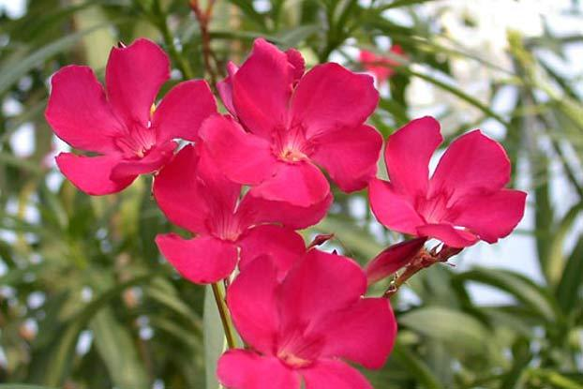However, in most cases people are unable to identify the plant that caused their illness, complicating their treatment. For example, the Oleander (Nerium oleander), which can cause seizures and even comas if ingested, many won’t know the name of the plant and when describing it, a “pink flower” isn’t going to help much, there are over 1500 unique species of “pink flower”[6]. By taking a photo using my program (when it becomes an app) and giving the name (scientific or normal) to the emergency services, will enable the patient to be treated quicker. The emergency services are able to bring the correct cure to them or have the cure ready and waiting for them.

## How to use Google Lens on your iPhone or iPadResearching the Problem

## Existing Solutions

### Google Lens

Google Lens is an image recognition technology developed by Google, designed to bring up relevant information related to objects it identifies using visual analysis based on a neural network[7]. This is very advanced but can be inaccurate. Furthermore as it is not specific to plants, it provides a base level of information, and if the user would like to research more about the plant, they will have to do that themselves, they also may not find correct data about the plant as they may get confused with another similar plant, therefore the user experiences a longer time to obtain data that can easily be solved with my program, which cuts out the need for users to find their own research as they will be provided with trustworthy information. Google has created an API for certain aspects of their many programs, and I plan to make use of the image recognition API created by them. The API only allows an image to be uploaded, and I can build my program around this, making use of the API. This is a reliable way to identify images, and using an image recognition software that is specially designed for plants would further improve its ability to provide an accurate output, as there is always the possibility that the output is wrong.

### Pl@ntnet

Pl@ntnet is an example of a pre-existing plant identifier, it allows the user to take a photo of a plant and returns only the name. As it is just a plant identifier, it doesn't provide the user with the detailed level of information about the plant that my program will, and therefore like existing image recognition (google lens) the user will have to do their own research, and this causes the same issue of prolonging a simple task that can be solved with my solution. Pl@ntnet is an open-source project meaning that the source code is accessible to the public, I would like to transfer this feature to my own, for the potential collaborations with other companies. Pl@ntnet has an educational focus, meaning it aims to provide users with information about the plant, which is something that I admire as it can cause the user to have a better final experience.

### PictureThis

PictureThis is another mobile application designed for plant identification. Similar to Pl@ntNet and other plant identification apps, PictureThis allows users to take pictures of plants and receive information about the identified species. This app is tailored towards providing cultivation tips to the user, which is one the features that I will include in my program making use of the API which I have selected. I will be making use of the way that PictureThis lays out the cultivation tips and use a similar layout. Similar to Pl@ntNet, PictureThis includes educational content to help users learn more about plants and gardening. Which as mentioned above, is something that I will be transferring over to my program. However, PictureThis is a paid for service, which is something that I will not be carrying over, as my program will be free for everyone to use, as well as being open source.

### PlantSnap

PlantSnap is another mobile app that is designed for allowing users to take a *snap* of the plant and then upload it to their website where, they use their database to identify the image. This program uses Machine Learning technology and artificial intelligence to help anyone, anywhere, identify any plant or tree on planet Earth![8] What makes PlantSnap different from previous programs, is that similar to my idea, the program aims to minimalize human input and provides information instantly, compared to other programs like Pl@ntNet who only provide a Wikipedia page link. Which is something that can greatly improve the usability of my program as it provides a better end result and greatly improves user welfare. Additionally, a feature that sticks out is the use of augmented reality (AR) to create and auto detect-feature. PlantSnap has an iOS feature that allows the app to tell the user when to *snap* the photo so that the user uploads the photo perfect every time. With the incorporation of this feature into my program, I am able to eradicate one of the issues, which is the AI not being able to tell the difference between the focused object and background objects.

### Blossom

Blossom is yet another app that is similar to my idea, however where my program only provides advice to the user about taking care of their plants, Blossom takes it a step further and even allows users to set up alarms and timers to “water, fertilize or repot your plant.”[9]. Furthermore by using the blossom app, as well as the standard features such as image recognition, you also get **5** additional features that not many programs have, for example already mentioned previously, the feature to set and create alarms, but also a botanist hotline, where the user is able to call an expert and have them give personalised treatment tips, the program also includes a light meter, to find the ideal spot for your plant, however this is only for android. The app also has the option for users to do an advanced search where users can look for new plants to grow based on a customised criterion, such as care difficulty, plan type, pet safety and more. Lastly users are able to create notes for their individual plants, allowing them to monitor how they grow or change.

## Review of existing solutions

As listed above from the pre-existing solutions, there are some features that I admire from each one and would like to incorporate into my own project, Below is a list of the programs and the features I’d like to incorporate into my program.

* From Google lens, I aim to use the image recognition aspect. This will allow me to start the first steps of my program where the user will upload an image, and using google lens will enable me to generate correct responses to the user’s image, whilst being as accurate as possible, as this aspect was made and designed by google, a trusted manufacturer.
* From Pl@ntNet, I’d like to make use of the educational aspect that is included with their program. For my project, one of the main features is to provide accurate information about the plant uploaded and therefore it would be most beneficial for the users to include this, whilst also teaching the user about the plant. This can help solve the problems that my client and potential stakeholders may have – lack of information. Additionally, like Pl@ntNet, I’d like to keep my project open source, so that in the future it can be modified or improved by other programmers.
* From PlantSnap, I would like to include their augmented reality (AR) auto detection feature into my program, this is because with the inclusion of this into my program, I will be able to reduce the room for error. Due to the nature of my project and the specificity needed for the AI to accurately provide correct responses, there has to be minimal room for error, and as mentioned previously the inclusion of AR would be beneficial to my program. A possible error that the users might face is having background objects(like other plants) in the image, messing up the identification process, and in order to streamline this, making use of something like the AR solution that PlantSnap can be really beneficial.
* From Blossom, I think that their advanced search is really smart, this is because it offers an additional feature that most programs similar to it don’t have or include, and it can provide an advantage for the business which is finding related plants to the one the user uploads, that the user might want or might be interested in, the user will therefore need to use my program again to maintain their new plants.

## Interviews

In this section, I will conduct interviews with existing clients and potential stakeholders to gain insights into why my program aligns with their requirements and how I can further tailor my solution to meet their specific needs. Through these interviews, I aim to find existing challenges faced by the clients so that I can refine and enhance my solution to fix these existing problems.

##### Jamie Burke interview questions and response:

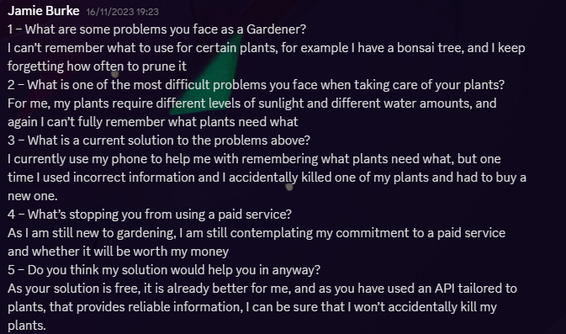**1 – What are some problems you face as a Gardener?**

I can’t remember what to use for certain plants, for example I have a bonsai tree, and I keep forgetting how often to prune it

**2 – What is one of the most difficult problems you face when taking care of your plants?**

For me, my plants require various levels of sunlight and different water amounts, and again I can’t fully remember what plants need what

**3 – What is a current solution to the problems above?**

I currently use my phone to help me with remembering what plants need what, but one time I used incorrect information and I accidentally killed one of my plants and had to buy a new one.

**4 – What’s stopping you from using a paid service?**

As I am still new to gardening, I am still contemplating my commitment to a paid service and whether it will be worth my money

**5 – Do you think my solution would help you in anyway?**

As your solution is free, it is already better for me, and as you have used an API tailored to plants, that provides reliable information, I can be sure that I won’t accidentally kill my plants.

##### 999 Call Operator interview questions and response:

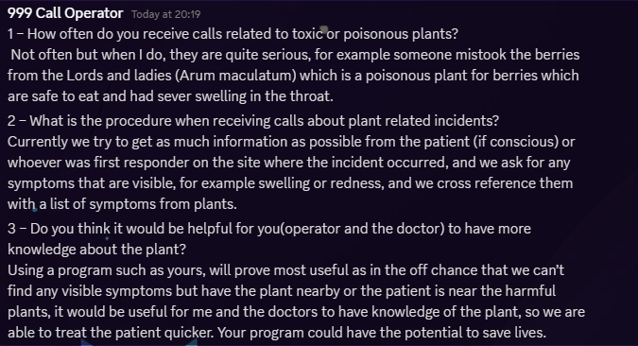**1 – How often do you receive calls related to toxic or poisonous plants?** Not often but when I do, they are quite serious, for example someone mistook the berries from the Lords and ladies (Arum maculatum) which is a poisonous plant for berries which are safe to eat and had sever swelling in the throat.

**2 – What is the procedure when receiving calls about plant related incidents?** Currently we try to get as much information as possible from the patient (if conscious) or whoever was first responder on the site where the incident occurred, and we ask for any symptoms that are visible, for example swelling or redness, and we cross reference them with a list of symptoms from plants.

**3 – Do you think it would be helpful for you (operator and the doctor) to have more knowledge about the plant?** Using a program such as yours, will prove most useful as in the off chance that we can’t find any visible symptoms but have the plant nearby or the patient is near the harmful plants, it would be useful for me and the doctors to have knowledge of the plant, so we are able to treat the patient quicker. Your program could have the potential to save lives.

##### Pl@ntnet colleague interview questions and response:

Hugo Gresse - Mobile engineer for Pl@ntNet

**1 – Could you walk me through the steps in order to obtain a result?**

1. Image Capture - Users take a photograph of a plant using the camera on their mobile device.
2. Image Recognition - The app utilizes image recognition technology to analyse the visual characteristics of the plant in the photograph.
3. Database Comparison - The app compares the identified features with a vast database of plant images and information.
4. Matching Algorithm - Pl@ntNet employs algorithms that compare the visual characteristics of the plant in the photo with those in its database. These algorithms may involve machine learning and computer vision techniques.
5. Identification Result - The app provides users with the most likely identification of the plant species based on the analysis. It may offer additional information about the identified plant, such as its common name, scientific name, and ecological information.
6. User Feedback - Users may have the option to provide feedback on the accuracy of the identification, helping to improve the system over time. This feedback loop is crucial for refining the app's algorithms and enhancing its performance.

**2 – How and why did you come up with this solution?**

Pl@ntNet was developed to address the challenge of plant identification, leveraging the increasing availability of mobile devices and the power of image recognition technology. The project originated from a collaborative effort between French research institutions, including CIRAD (French Agricultural Research Centre for International Development), INRAE (French National Institute for Agricultural Research), IRD (French National Research Institute for Sustainable Development), and Tela Botanica, a French network of botanists and plant enthusiasts.

**3 – How does your program identify the image?**

The process by which Pl@ntNet identifies plant images involves complex algorithms and techniques in the field of computer vision and machine learning. While I may not be able to share the specific details of Pl@ntNet's algorithms I can provide a general overview of the typical steps involved in image identification systems.

* Image Preprocessing - The input image is pre-processed to enhance its quality and highlight relevant features. This may include tasks such as resizing, normalization, and filtering.
* Feature Extraction - The system identifies key features in the image that are relevant to plant identification. These features could include the shape of leaves, the arrangement of petals, the presence of specific patterns, and more.
* Descriptor Generation - Descriptors are numerical representations of the identified features. These descriptors capture the essential information needed for comparison and matching.
* Database Comparison - Pl@ntNet compares the generated descriptors with a large database of plant images and associated information. The database likely contains images of various plant species along with their known characteristics.
* Matching Algorithm - The system employs a matching algorithm to compare the descriptors of the input image with those in the database. This algorithm aims to find the closest matches based on similarity scores.
* Probabilistic Output - Instead of providing a definitive answer, the system may generate a list of potential matches ranked by confidence levels. This probabilistic approach acknowledges the uncertainty inherent in plant identification and allows users to interpret the results accordingly.

**4 – where do you get your data about the plants from, is it from an API or do you have your own database?**

Pl@ntNet has its own database of plant images and information, and it doesn't rely on external APIs for its core functionality. The database is compiled from various sources, including contributions from users of the app, botanical experts, and collaborations with botanical organizations

**5 – what stops people from using other programs such as google lens, what makes yours different?**

Pl@ntNet stands out from other similar plant identification programs for several reasons, and these distinctions contribute to its popularity and effectiveness. Here are some key factors that make Pl@ntNet different from other programs.

* Citizen Science Emphasis - Pl@ntNet emphasizes citizen science, encouraging users to actively participate in plant identification. Users contribute images and information, which helps improve the accuracy of identifications and enriches the database.
* Educational Focus - Pl@ntNet serves as an educational tool, providing users with information about identified plants. This educational focus aligns with the goal of increasing public awareness and understanding of biodiversity.

## Deduction from interviews

Through these interviews, I have been able to understand potential improvements for my program. It was evident that the existing challenge revolved around the stakeholders not wanting to purchase a paid service, and how with existing programs there is the problem of imperfect or incorrect data. The solution lies in my program which is able to provide reliable information for free. The questions with a 999 operator have shown me their current procedures. With this knowledge, my program has the potential significantly improve the efficiency of this. Furthermore, the interview with an engineer for Pl@ntNet was especially helpful as it gave me valuable information on their application. Understanding the user interaction process has provided a solid base which my program can be based around. Being heavily inspired by the way Pl@ntNet tackles this problem, I aim to create a user-friendly interface that optimally addresses the specific needs and expectations of the end-users.

These interviews have allowed me to evaluate my program at its current state, making room for changes to better it, and they have given me new perspectives on the challenges faced by emergency operators and my client. As I continue on the development phase, these ideas will provide me with a bases of what I need to improve on.

## User Requirements

* Log In Screen – The gateway to the application, this feature provides users with a secure platform to authenticate their identities, granting access to their respective accounts, allowing the users to utilize the full spectrum of the program's features and functionalities.
* Image Recognition – This innovative feature makes use of advanced algorithms to provide users with a seamless and intuitive method for inputting data. By just taking a photo, users can effortlessly input information to the program, which then employs image recognition technology to accurately interpret and analyse the visual data, and eventually providing reliable outputs.
* Data Output – Within this section, users will be given detailed profiles for the data they gave in the image recognition section above, each containing essential information tailored to meet their needs. For instance, users will be provided crucial information for nurturing their plants effectively, such as optimal watering schedules, ideal sunlight exposure, and recommended soil types. Additionally, vital data for safety and risk assessment purposes may also be provided. Users can quickly access this information in the output screen, where the information will be bullet pointed for easy understanding.
* Image confirmation – A potential issue users may encounter is receiving results for a different plant species than the one they input due to similarities between plant appearances. To mitigate this, my solution incorporates an image confirmation feature. Upon receiving results based on the user's initial image input, the program will also display a reference image of the identified plant. This reference image serves as a visual confirmation for the user, allowing them to compare it with their original input image to verify accuracy. This verification step will enhance the user confidence in the provided information and reduces the risk of receiving incorrect results due to visual similarities between different plant species.

## Measurable Requirements and Success Criteria

### Measurable Requirements

* Program should load within 6 seconds of opening – if all files and data are correct
* Once the program has loaded, user should be able to log in to their account, view all saved files once opening within a few seconds of opening the program, or create a new account.
* Once taking a picture and uploading it to the software, the program should provide a correct response within a few seconds of receiving it.
* Overall information should take no longer than a minute, if Wi-Fi speeds are optimum and connection is strong, or mobile data has a stable connection.
* Program must close within a reasonable time after pressing the *x* orclose window button.
* Program AI must be able to differentiate between focused object in image and background image.

### User Requirements

* The Image that the user takes must be clear, and specifically just the plant, with little to no background images.
* The user must be connected to the internet to access the information pulled from the API which may not be most convenient to the user.
* The AI must be trained to recognise different plants which could be time consuming as I have never done this before and will add an additional level of difficulty and challenge to my project.

### Success Criteria

* Able to identify an image and provide an output (for testing) to confirm that the AI can correctly identify the plant.
* Pull relevant key data from an API based on the input provided by the user, for example optimal watering schedules, ideal sunlight exposure, and recommended soil types.
* Return all data on the image in a user-friendly manner, with a picture of the original picture that the user took. The data will include full scientific name and optimal living conditions, and other data based on the plant

## Limitations

Due to time constraints, with only five months available for development, it's unlikely that all desired aspects of the program will be fully researched and integrated into the final product. This limited timeframe poses challenges, particularly when dealing with new features such as image recognition and the incorporation of AI. As these elements are relatively new to me, there's a learning curve involved in understanding and implementing them effectively within the program. Consequently, while striving to include these features, there may be instances where their implementation falls short or they don't perform as expected, necessitating consideration of alternative approaches. For instance, instead of relying on AI to search an online database, one alternative approach could involve utilizing a locally stored file containing approximately 100 images of common plants found in the user's location. The AI could then compare the user's input with the images in this database, selecting the closest match and providing an output based on that comparison. However, this alternative method introduces certain drawbacks that may not align with the preferences of my clients. For instance, one of my clients' concerns revolves around imperfect knowledge leading to inadvertent harm to plants. By not utilizing a comprehensive online database, the accuracy of the results may be compromised. Similarly, in the context of emergency situations handled by 999-call operators, inaccurate information could potentially exacerbate the severity of the situation. Nevertheless, the utilization of a locally stored database offers the advantage of offline functionality, allowing the program to be accessible even without an internet connection. While this may increase the program's size, it enhances its usability in scenarios where internet access is limited or unavailable. Despite the challenges posed by time constraints and the incorporation of new features, exploring alternative solutions ensures that the program remains adaptable and responsive to the needs of its users.

## Hardware and Software Requirements

* Able to successfully identify the desired plant and pull relevant information from the API.
* Program must be able to tell the difference between a picture of a plant and something that is not a plant.
* In order to “see” the image there must be a way for the program to access files, upload images to the program.
* While there's a slight chance of me exploring the idea of developing a mobile app, it's worth noting that my current expertise might not be sufficient for such a venture. However, should I decide to pursue this path, the application would need to have the capability to interact with the device's files and camera.

### Hardware Specification

|  |  |  |
| --- | --- | --- |
|  | Minimum | Recommended |
| OS | Windows 10/11 64-bit | Windows 10/11 64-bit |
| Processor | Intel Core i3-5th generation or equivalent | Intel Core i9-14th generation or equivalent |
| Memory | 6GB RAM | 16GB RAM |
| Storage | 5GB available space | 1TB available space |
| Graphics | Integrated graphics(any) | NVIDIA GeForce RTX 4090 |

## Justification for hardware specifications

### Justification for Minimum

The operating system is limited to Windows, as macOS utilizes a different architecture, meaning the program won't be optimized for it and may not fully function. Additionally, regarding the processor, it still has to be supported by Intel. Adequate memory is necessary for the device to run smoothly and allocate resources to the program effectively. Sufficient storage is vital to accommodate all the code and photos used in the database. As for graphics, the program requires only the bare minimum to provide a visual interface to the user.

### Justification for Recommended

The operating system is exclusively Windows-based, and the program is developed specifically for this platform. However, it's essential to recognize that the macOS operates on a different architecture, rendering the program less optimized and potentially leading to partial functionality. For the processor, to ensure the program runs at its peak efficiency, Intel's latest chip or an equivalent model is recommended. Adequate memory is necessary to sustain device operations while allocating sufficient resources to the program. In terms of storage, it must be capacious enough to contain all code and database photos. Additionally, since the database is open source, users may enhance it with higher-quality images, increasing the file size accordingly. As for graphics, the program recommends the latest graphics processor to deliver the highest definition visuals, enabling users to view images in the best available quality.

# Design

In this section, I will breakdown the solution into its fundamental components, clearly layout how each component seamlessly transitions into the next, while establishing clear interconnections among all parts. Furthermore, I will enhance comprehension by incorporating diagrams to visually illustrate the decomposition of each section. Additionally, I will be outlining a possible contingency plan to address any unforeseen challenges that may arise.

## Decomposition

### Decomposition Diagram for Reverse Image Searching

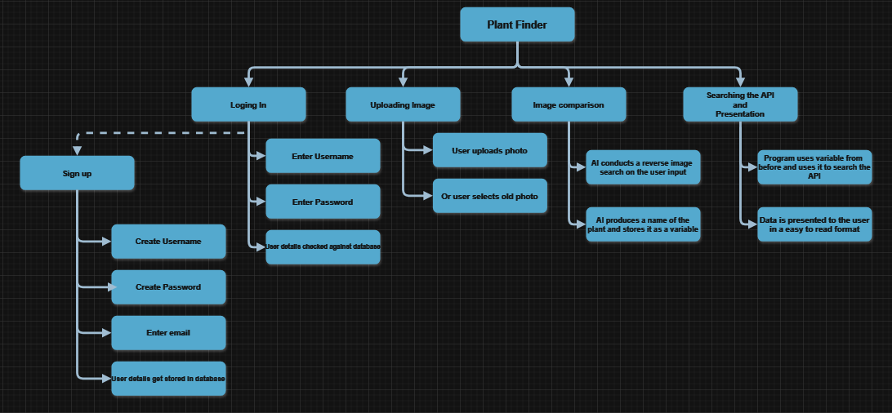

### A diagram of a company Description automatically generatedDecomposition Diagram for Image Comparison – added later

The diagrams above show the “flow”, of the program from left to right. There are 5 main components that my solution can be broken down into. These are Signing up, logging in, uploading an image, Image comparison and searching the API and presentation. As show in the diagrams, I have broken down each component into its core aspects and what data it will take in, and the steps that taken to fulfil each key part. The sign in part is using a different arrow, this is because not all users will use this feature. This is a onetime feature that users will make use of on their first interactions with the program, and then not have to use this again as once they’ve created an account, they can now log into that account.

### Loging in and Signing up

The initial startup of the program serves as the user's gateway, setting the first impressions of the program. It is a vital component that must seamlessly integrate multiple aspects to ensure the user can navigate and utilize the program to its fullest.

* One function of the program is the ability for users to create an account. This involves a friendly interface that will easily allow for users to create a new account, collecting necessary information such as a username, password, and email, ensuring its secure storage in a database. Secure storage of user information is paramount to protect user privacy and prevent unauthorized access.
* Another feature of the program is allowing the users to log in to their already existing accounts. This requires a secure authentication mechanism, and safeguarding user credentials by having them validated by the database, reducing the risk of unauthorized access or data breaches. Validating user credentials against a database adds an extra layer of security. By verifying the authenticity of user-provided information, the program can safeguard against malicious activities like account hijacking or unauthorized access.
* Once logged in, users should be able to easily access their past uploads and search history. This involves implementing a search history function that stores and saves users previous searches A user-friendly dashboard or history page is crucial for presenting this information in an organized and accessible manner. It enhances usability and makes it easier for users to navigate and interact with.

In essence, the front-end aesthetic and back-end structure must collaborate together to deliver a user-friendly experience. The interface should not only be visually appealing but should also prioritize functionality and efficiency.

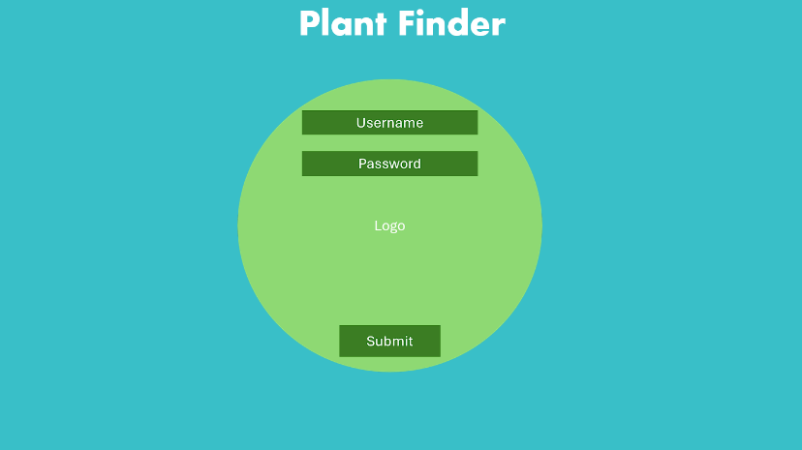Here is an image showcasing a proposed design for the login page, which will be the first thing users see when they open the program. This design boasts simplicity and cleanliness, making it incredibly intuitive for users to understand both what actions to take and how to execute them effortlessly.

### Permanent Data storage

When signing up, users are required to provide essential information, including a username, password, and email address, which serve as their credentials for accessing the program. This data collection is integral to creating personalized user accounts, enabling functions like secure account access and password recovery. In response to the General Data Protection Regulation (GDPR), the program must abide by this. Adhering to the General Data Protection Regulation (GDPR) ensures transparency, integrity, and confidentiality in handling user data. Ensuring the integrity and confidentiality of user information necessitates a secure database infrastructure with robust security measures, such as encryption and access controls, to protect against unauthorized access or disclosure, thereby safeguarding user data and enhancing platform security and user trust.

### Uploading image

This pivotal feature is not just one component of the program but forms the backbone of the program's interaction with users. Within this section, users are presented with a unique opportunity: the ability to upload images to the program for analysis by the artificial intelligence (AI) algorithms. This process involves a well-built user interface that guides individuals through uploading an image. This involves clear instructions, file format and compatibility guidelines. This reduces any potential problems for this interaction.

* An essential feature is the program's ability to save uploaded images. A secure and variable database infrastructure would be needed to store these files.

In summary, the image uploading feature allows for the user interaction and artificial intelligence capabilities to start working to produce an end result that ensures a good user experience.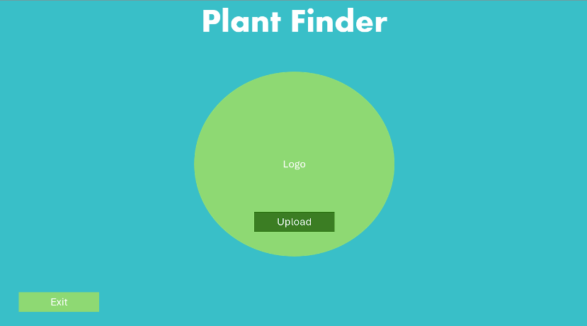

Here is a proposed design concept for the homepage that users will encounter upon successfully signing in. The design prioritizes a clean, aesthetically pleasing, and intuitive layout to ensure ease of use and minimize confusion, thereby enhancing the overall user experience.

### Image recognition

This is one of the most prominent features that allows this program to stand out. This feature allows the users uploaded images of plants, to have an interaction with the program's AI. The algorithms that the AI will use, will be able to acknowledge the presence of an image and delving deeper by providing a name of the plant. The complexity of plant recognition demands the ability differentiate between plant species.

* The user interface is important as it will guide users what they need to do. This interface will not only allow the upload of images but also offers real-time feedback on the recognition progress. Furthermore, error-handling should be seamlessly integrated, providing feedback when an uploaded image deviates from the parameters of plant recognition.
* Another defining feature of the program is for the AI to recognise the image of the plant that is uploaded and will be able to identify the image of the plant and output a result, or output an error if it is not a plant

Upon successful recognition, the program should deliver an output that will later be run through an API, which will then provide useful data.

### Searching the API

The integration of the image recognition aspect within the program opens up the possibilities for users to delve into information about their input. The choice of API is crucial, ensuring that it aligns seamlessly with the program's job. An API with a vast database allows the program to offer users an extensive array of information about the recognized plants, of which users can take advantage, enriching the overall user experience. The programs will send requests for specific data associated with the identified plants and provide them with information that they can pick.

Overall, the integration of an API for information retrieval amplifies the program's capabilities, transforming it into an interactive knowledge hub for plant enthusiasts.

## Structure of solution

Initially, users will be prompted to either log in or sign up, providing them with access to the program's diverse features. After entering the program user will be given the options to explore their past uploads or upload a new image. If users want to upload a new image, the system will save the visual data. The uploaded image undergoes an intricate process to identify the details of the plant. Following successful identification, the program seamlessly assigns a name to the plant, through the use of the AI. This name, now linked to the uploaded image, serves as the key to advancing to the next stage. The program conducts a search through the API dedicated to botanical information. The result of this exploration is an output that present users with a blend of visual and informational elements. The user is presented with the captivating image of the identified plant and lots of botanical insights sourced from the API. To summarise, the user's journey will include effortlessly moving from the logging in phase to image upload section, then intelligent recognition, plant naming, and finally the presentation of plant information.

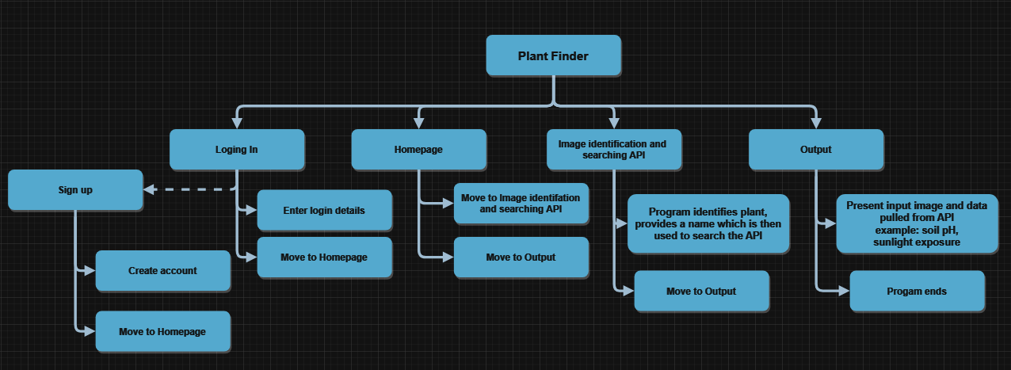

The picture above shows the initial structure of my program and how each step moves to the next

## Contingency

As a contingency for the AI doing a reverse image search and then searching the API on the user’s photo input, although this would be the best, most optimal and reliable method of completing my program, due to certain time constraints and a lack of aptitude surrounding this method, there must be a backup plan in order for the program to continue working.

This backup plan consists of still using an AI, or complexed program that will compare two images but instead of using the AI to conduct a reverse image search it will use an AI to compare two images together. This will work by having the use have a local database of around 50 images (this will increase the programs size). The database will include a variety of plants in an attempt to still be as accurate as possible in these circumstances. Once the user has uploaded the image of their plant to the main program, the AI will then search all images in the database and see what one is most similar. Then the program will aim to provide an output for the plant, which will contain a name of the plant, which will then be used to search the API and provide the same information that would have been provided before.

With this contingency plan, there are obvious drawbacks such as the accuracy of the image searching and the user could receive incorrect information, therefore a disclaimer would have to be present, so that the user is aware that the program is not as accurate using this method. This version of the program will make use of an equation such as the Mean Squared Error, which measures how close a regression line is to a set of data points.

A regression line(analysis) is a method used to understand the relationship between two or more variables.

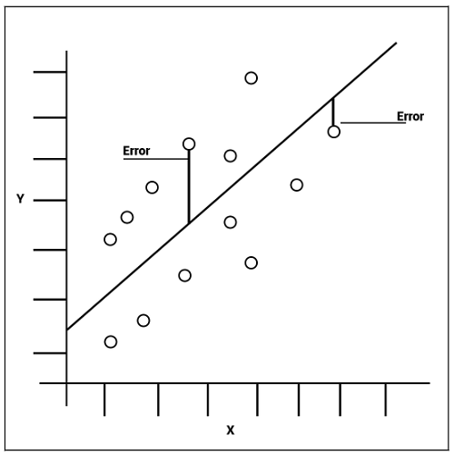The output of the MSE/ image comparison will be a long number, at face value this will mean nothing to the user. The output is given as a long number when comparing two or more images, a comparison will be made between them and then an output will be provided. This output will determine how similar the two images are, a larger MSE value means that the images are similar, and vice-versa if the MSE value is smaller, then it means that the images are not similar.

Shown by the graph, errors that are closer to the line mean that the images are similar and will therefore provide numbers closer together.

## Success criteria – Updated

Original success criteria -> Success Criteria

**After implementing the contingency plan, a new success criterion is needed, including any new criteria from the revised solution. The new criteria will be a replacement for the original success criteria.**

* Program is able to take an image as an input and store it.
* Able to convert all images to greyscale.
* Able to plot key points on all images that can be used to compare the images.
* Able to provide an MSE result for all image comparisons done.

## Structure of solution – Updated

Original structure of solution -> Structure of solution

**Following the implementation of the contingency plan, there is a need for a revamped structure to reflect the changes in implementation. This will be a replacement for the original structure of my solution.**

Initially, users will be prompted to either log in or sign up, granting them access to the program's diverse features. This step is essential for user authentication and personalized access to the platform's functionalities. Upon entering the program, users will be presented with the option to upload a new image, engaging them directly with the platform's primary service. The uploaded image will then undergo an identification process, now utilizing a method of image comparison. This approach involves comparing the uploaded image with a vast database of other images, employing a complex Mean Squared Error (MSE) equation for detailed analysis. The user will receive a numerical value as a result, indicating the most likely image comparison outcome. To summarize, the user's journey will seamlessly transition from the login phase to the image upload section, culminating in intelligent image recognition, which is crucial for delivering value and functionality to the users while maintaining the program's relevance and competitiveness in the market.

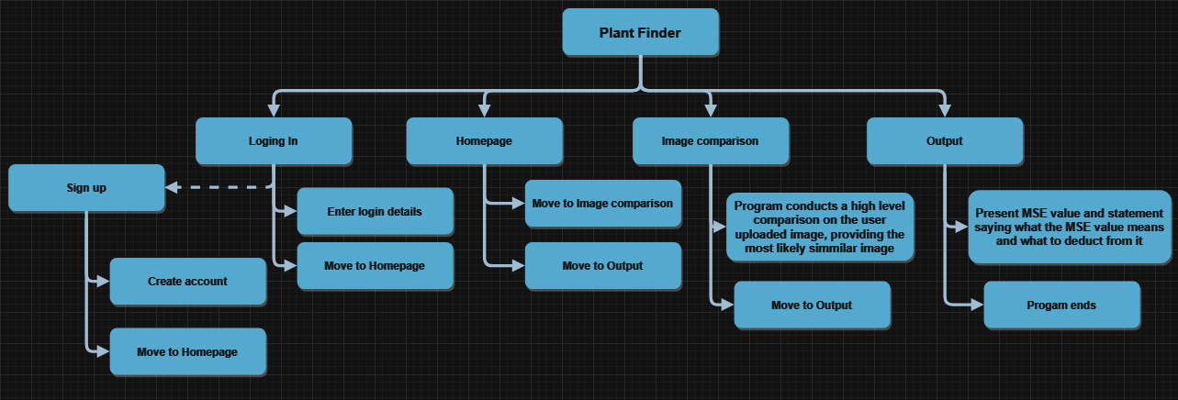

## Algorithm design for solution

Below is the pseudocode outlining the main sections of the project. This serves as a blueprint guiding the development of the main code. Clear identification of each section within the pseudocode is crucial, ensuring that when presented to clients and potential stakeholders, they can easily comprehend how the program functions. This provides them with a concise overview of how their problem will be addressed and solved through the software.

### Pseudocode for reverse image search

Start

Procedure UserLogin():

- Get user credentials (username, password)

- Validate user credentials

- If credentials are valid, proceed to image upload

- Else, notify the user and terminate

Procedure ImageUpload():

- Prompt user to upload an image (in PNG or JPG format)

- Receive the uploaded image file

- Validate the file format (PNG or JPG)

- If valid, proceed to reverse image search

- Else, notify the user and terminate

Procedure ReverseImageSearch(image):

- Use AI to perform reverse image search on the uploaded image

- Get the scientific name of the plant from the search results

- Store the scientific name and uploaded image in the pastSearches hash table

Procedure BotanicalAPISearch(scientificName):

- Use the scientific name to query a botanical API

- Receive multiple outputs in the form of text

- Display the results to the user

Procedure ViewPastSearches():

- Retrieve and display past searches from the pastSearches hash table

Procedure Main():

- Call UserLogin() to authenticate the user

- If authentication is successful, call ImageUpload()

- If image upload is successful, call ReverseImageSearch() with the uploaded image

- If scientific name is obtained, call BotanicalAPISearch() with the scientific name

- Display the results to the user

- Prompt the user if they want to view past searches

- If yes, call ViewPastSearches()

End

**UserLogin():**

* Ensures that only authorized users can access the image upload and search functionalities.
* Validates user credentials to ensure security and prevent unauthorized access.

**ImageUpload():**

* Allows users to upload images of plants in PNG or JPG formats.
* Validates the file format to ensure that only supported image types are processed.
* Provides a starting point for the reverse image search process.

**ReverseImageSearch(image):**

* Utilizes AI to identify the uploaded plant image and retrieve its scientific name.
* Stores the scientific name and the uploaded image for future reference in the “pastSearches” hash table.
* Links the uploaded image with its botanical information for further querying.

**BotanicalAPISearch(scientificName):**

* Queries a botanical API using the obtained scientific name to fetch detailed information about the plant.
* Receives and displays textual outputs related to the plant's characteristics, habitat, etc.
* Enhances the user's knowledge about the identified plant beyond just its name.

**ViewPastSearches():**

* Allows users to revisit their previous searches stored in the “pastSearches” hash table.
* Provides a history of identified plants.

**Main():**

* Starts the entire process by calling the individual procedures in a sequential manner.
* Ensures a smooth flow from user authentication to image upload, reverse image search, botanical information retrieval, and viewing past searches.
* Provides a user-friendly interface by displaying relevant information and options at each step.

### Pseudocode for image comparison

Start

Procedure UserLogin():

- Get user credentials (username, password)

- Validate user credentials

- If credentials are valid, proceed to image upload

- Else, notify the user and terminate

Procedure ImageUpload():

- Prompt user to upload an image (in PNG or JPG format)

- Receive the uploaded image file

- Validate the file format (PNG or JPG)

- If valid, save the image to the "img" folder

- Else, notify the user and terminate

Procedure PreprocessImage(image):

- Convert the image to grayscale

- Extract key points or features for comparison

- Return the preprocessed image and key points

Procedure CompareImages(userImage, databaseImage):

- Preprocess both userImage and databaseImage using PreprocessImage()

- Use Mean Squared Error (MSE) equation to calculate the similarity probability

- Return the similarity probability as an integer

Procedure SearchDatabase(userImage):

- Get a list of all images in the "img" folder

- Initialize maxProbability to 0

- Initialize bestMatchName to an empty string

- For each image in the "img" folder:

- Calculate similarity probability using CompareImages(userImage, databaseImage)

- If probability is greater than maxProbability:

- Update maxProbability with the new probability

- Update bestMatchName with the name of the current image

- Store userImage and bestMatchName in the pastSearches hash table

- Return bestMatchName

Procedure BotanicalAPISearch(imageName):

- Use the imageName to query a botanical API

- Receive multiple outputs in the form of text

- Display the results to the user

Procedure ViewPastSearches():

- Retrieve and display past searches from the pastSearches hash table

Procedure Main():

- Call UserLogin() to authenticate the user

- If authentication is successful, call ImageUpload() and get userImage

- Call SearchDatabase(userImage) to find the best match image in the "img" folder

- Call BotanicalAPISearch() with the best match image name

- Display the results to the user

- Prompt the user if they want to view past searches

- If yes, call ViewPastSearches()

End

**UserLogin():**

* Ensures that only authorized users can access the image upload and search functionalities.
* Validates user credentials to ensure security and prevent unauthorized access.

**ImageUpload():**

* Allows users to upload images of plants in PNG or JPG formats.
* Validates the file format to ensure that only supported image types are processed.
* Provides a starting point for the reverse image search process.

**PreprocessImage(image):**

* Converts the uploaded image to grayscale, simplifying the image data and reducing computation.
* Extracts key points or features that are essential for comparing the user's image with database images.

**CompareImages(userImage, databaseImage):**

* Uses the Mean Squared Error (MSE) equation to calculate the similarity probability between the user's image and each image in the database.
* Provides a quantitative measure of similarity to identify potential matches.

**SearchDatabase(userImage):**

* Scans the “img” folder to retrieve a list of all stored images.
* Compares the user's image with each database image using the CompareImages procedure to find the best match.
* Stores the user's image and the best match's name in the “pastSearches” hash table for future reference.
* Returns the name of the best matching image from the database.

**BotanicalAPISearch(imageName):**

* Queries a botanical API using the name of the best matching image to fetch detailed information about the plant.
* Receives and displays text outputs related to the plant's characteristics, habitat, etc.

**ViewPastSearches():**

* Retrieves and displays past searches stored in the “pastSearches” hash table, allowing users to revisit their previous identifications.

**Main():**

* Starts the entire process by calling the individual procedures in a sequential manner.
* Ensures a smooth flow from user authentication to image upload, reverse image search, botanical information retrieval, and viewing past searches.
* Provides a user-friendly interface by displaying relevant information and options at each step.

## Database Design

Below is an image of an Entitiy relationship diagram demonstrating how the users will interact with the database, and how the admin will interact with the database.

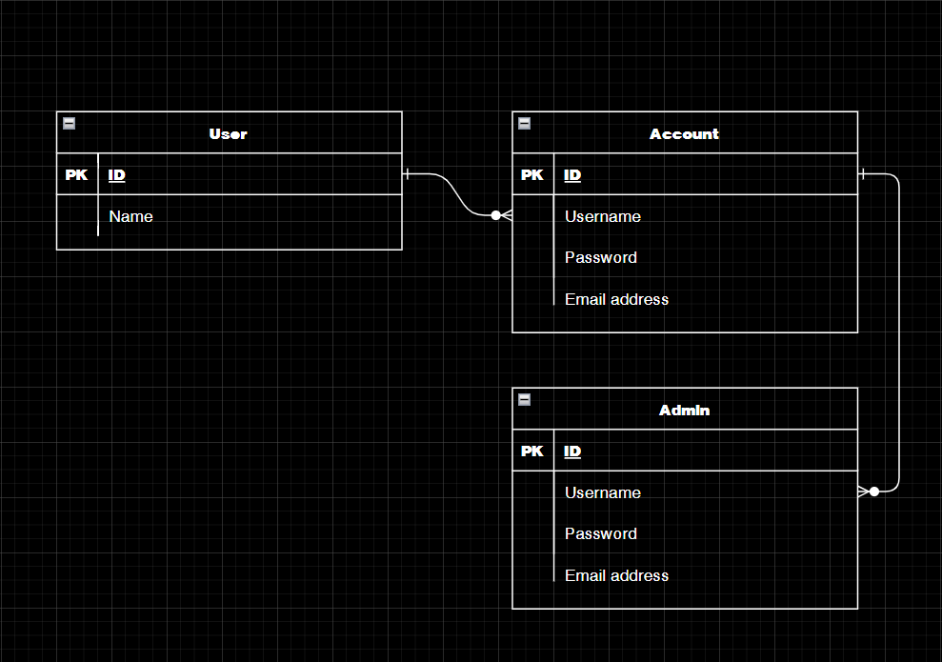 The diagram illustrates a one-to-many relationship, indicating that a single user can have multiple accounts. This design accommodates scenarios where users share a device with others and wish to maintain separate profiles to prevent mixing up their plant information. Each account comprises essential credentials, including a username, password, and email address, which are pivotal for user authentication and account management. The inclusion of an email address enables users to reset their passwords in case of forgetfulness, enhancing user convenience and security. Similarly, admin accounts are structured with the capability to manage multiple user accounts, a one-to-many relationship. The presence of an admin account is crucial for overseeing and troubleshooting potential issues on the client-side of the application. In the event of problems like forgotten passwords or technical glitches, the admin can intervene and provide assistance, such as resetting passwords or resolving system errors. This administrative oversight ensures smooth operation and user support, reinforcing the program's reliability and user satisfaction.

## Diagrams

### Program Overview

Presented below is a flowchart showing an overview of my program and its sequential steps. Flowcharts are particularly effective for providing a concise overview as they delineate each step clearly, illustrating the actions taken at each stage and the subsequent flow of the program. Through this visual representation, viewers can easily discern the program's order and understand how each step seamlessly transitions into the next.

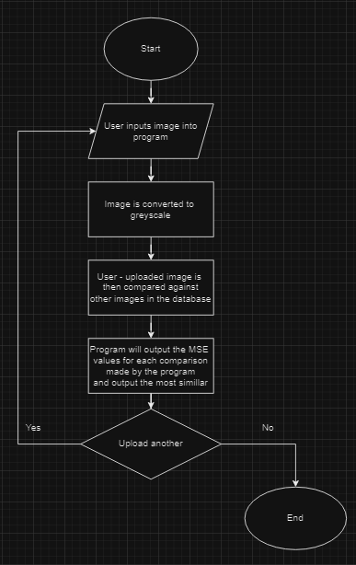

The user will have taken a photo of the plant and will upload it to the program. Ideally this will be in the size 720 by 720 and will be saved as a JPG file, as this is a requirement for other processes.

A crucial step before the image comparison is done, the user uploaded image must be converted to greyscale, this can only be done if the file is the same size as all other files (720 by 720) and stored as a JPG file.

A high-level comparison will be done where key points are plotted on all images (user uploaded and database) and then compared against each other to find the similar ones, the use will not see this being illustrated.

The program will provide a MSE value for each comparison done and then tell the user which flower is most similar to the one they uploaded.

After that, the user will be guided to the homepage where they will have the option to either upload another image, and in essence the program repeats itself, or the user can exit the program, signing them out.

### A diagram of a flowchart Description automatically generatedSigning In Process

When starting the program, users are given the option of either logging in with their existing account or creating a new account. This is where the program will verify the entered credentials against the database for existing accounts, or for users who want to create a new account, their details are stored within the database, waiting for future validation for the next time the user logs in. The design, as shown in the diagram, indicates how the details are stored and checked against the database. The interaction between user input and the database shows the security measures put in place ensuring the authentication of each username and password combination, guaranteeing the safety of user accounts. Following the successful verification or storage, users are granted access to their accounts, unlocking the rest of the program features.

### A diagram of a programImage Upload

Following a successful login or sign-up, users encounter a friendly process that allows them to submit an image for AI analysis. The step-by-step approach, illustrated by the diagram, allows for users to seamlessly upload one file at a time. The system allows the possibility of reconsideration many times before finally uploading the image. Once finalizing their image choice, the server takes charge, it will check to ensure that the uploaded file meets the program's requirements (being in a PNG or JPG file format). This verification process guarantees the compatibility of the data. Once the server verifies the file's format, it relocates the image to a designated folder that is accessible by the AI.

## Usability features

### A screen shot of a login Description automatically generatedLogin/Sign up

For the users first time boot up of the program they will be met with a clean, simple log in screen. This will give the user the chance to log in, or to create an account that they can log into for the future, this will be implemented as in the future; I aim to add a method to save the users photos and information about the plants they uploaded. Usability features in this section include error messages, and the feature to create an account (Optional). When there is invalid data inputted the user my not always be aware of this, and therefore appropriate error messages will be placed to indicate to the user that they have done wrong, this will help smoothen the process of logging in or signing up

The screen will look like this (image above). It is clear as to what to do, and therefore will be no confusion for the user. It has the software branding which will be a nice addition to welcome the user to the program.

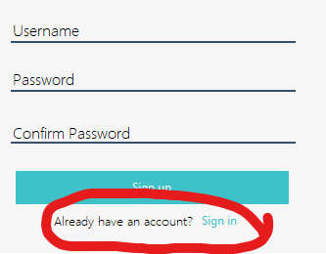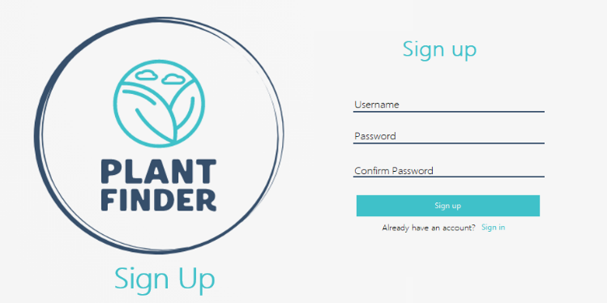Additionally, to keep everything cohesive but distinguishable, I have slightly changed to logo to make sure that the user is aware that the application has changed to the Sign-up window, and if not, the user can still go back to the previous one if this was a mistake by pressing the *sign-up* button, which will bring them back to the original window.

Justification for login function - The user gains access to the rest of the program through signing in, each user will be able to upload their own images of plants on their respective account, having a log in function separates user inputs. Sign in function is needed as not all users may have an account at first

### A screenshot of a plant finder Description automatically generatedHome Screen

When the user logs in they will be greeted with a clean user-friendly home screen which will be the main screen the user sees. On here the user will have the option to either upload an Image, or select an old file, and from there the program will do the required function. Or the user can exit the program. To reduce any confusion that the user has, there will be a step-by-step explanation of how to use the program, the user interface will be enough but as a second option, the user will be able to glance over at the easy to read and understand guide. Usability features in this section will include a two-step verification of exiting the program. Due to the nature of the program, when the user presses the exit button, they will be asked again if they are sure they want to sign out, this is because the program will log the user out when this button is pressed.

Justification for home screen – Once the User has logged in, they need a way to navigate the program to access the different features, for example a way to upload their image, or to exit the program, without the home screen they will not be able to do this

### A screenshot of a computerUpload Image

To allow for a straightforward way for the user to select the image of the plant they desire, a simple window would be most effective. This will allow the user to seamlessly open and upload the image so that the AI can determine what plant it is and then call upon the API to provide data customised to the users’ needs. Usability features in this section include a two-step verification of the image the user uploaded. After selecting the image they wish to upload, they will be able to see the name of the file, this acts as another method of verification, so that the user is sure they have selected the correct image. The GUI will look something like this. This simplistic design was made to allow for there to be little error, for users to mess up.

I have also added a drop-down text to further enhance the user experience, as I mention after, the user is only allowed to upload PNG or JPG file formats, now the user is able to hover over the information symbol and have the website display text that tells the user what file formats to use when uploading photos.

Justification for uploading an image – In order for the program to work as intended, the user will need to upload an image so that it can be used to return a result, therefore through this function, the user will be able to successfully upload a valid image and consequently move on to the next stage of the program.

### File Select

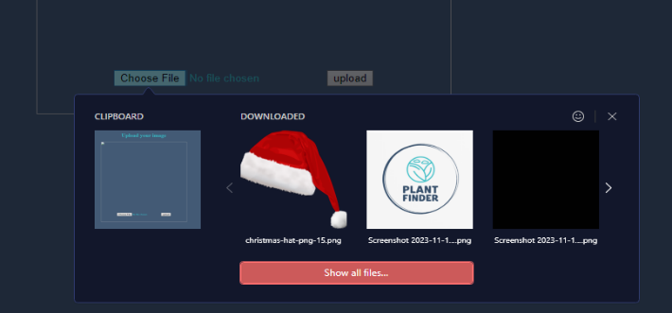When the user opts to select a file to upload to the program, they will be given the option to only select PNG or JPG files, and if they use a specific browser (Opera GX) they can upload the last image they screenshotted, or copied or they are given the most recent images. The usability feature in this section is blocking certain file formats that are incompatible for the program. The user will not be able to upload any other type of file format, leaving no room for error, or any way to break the system. This will assist the user in the use of my program, this coupled with the drop-down text mentioned in the section above (Upload Image), will work hand in hand to ensure the user encounters minimal errors.

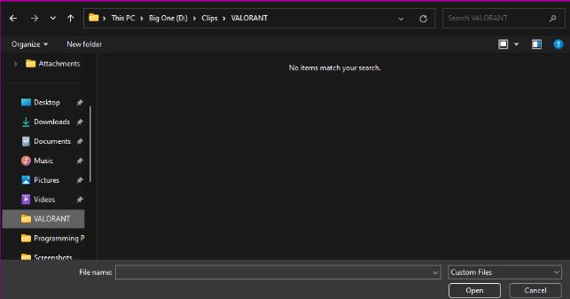As show by this image, when navigating to a folder with video file formats, as the user can see, they do not see any of their files, and are therefore not given the option to select and upload to the program. They are still able to search through all folders.

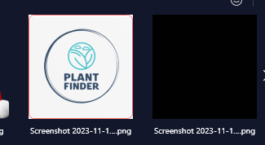When selecting what image to use, using opera GX (browser) as an extra precaution step, just so that the user is sure that they use the correct image a small orange box appears around the image.

As a final level of precaution for the name of the file is shown to the user just so they can make sure they have uploaded the right file.

Justification for file select – Once the user has chosen to upload an image, they have to browse through their files to find the image they want to upload, the way the program will be designed will be to minimise the time it takes to browse by only showing valid files. Furthermore, there will be an additional stage of verification where the user will be able to double check if they have uploaded the correct image. This is needed so that the user doesn’t waste their time and making sure that they have uploaded the correct image, making it easier to use the program.

### A screenshot of a computer Description automatically generatedViewing/Output

When viewing the requested information, the user will not want to sift through long sentences with the answers scattered throughout, I will display the user’s requested information in a simple, easy to understand and gather way. The usability feature in this section will be an image conformation which includes a picture of the plant which will act as a second method of verification for the user as they will be able to double check if they have uploaded the correct plant. The key information will be placed next to the plant. The output will look something like this.

Justification for viewing and output – Once the user has uploaded an image, they will need a way to easily digest the information provided, this will be done making use of computational methods(Computational Methods). This is needed as the user will have an easy way to view the information presented to them.

### Password Re-set

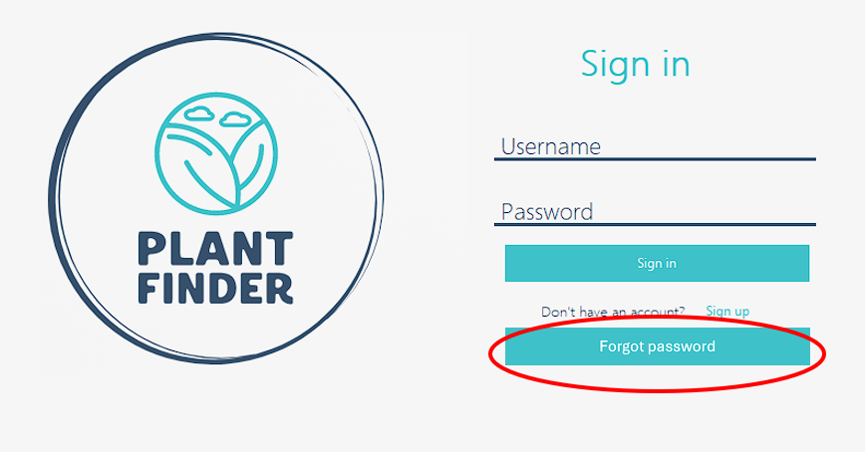In situations where a user finds themselves unable to recall their password, the integration of a password reset feature proves invaluable. This feature allows users to start a password recovery process. By simply selecting the "Forgot Password" option, the user can trigger an automated email sent directly to their registered email address. This email contains a link that redirects them to a dedicated password reset page within the program. Here, users can securely create a new password, ensuring the confidentiality and safety of their account. This streamlined and user-friendly approach minimizes stress and frustration, enabling users to regain access to their account promptly and with ease. The usibility feature in this setion will involve the user adding their email manually, this will then be checked against the database, adding another step of verification, so the user knows what email they sent it to.

Justification for password re-set – This is needed as, if the user has forgotten their password they need a way to log back into their account, without this function they will be locked out of their account, needing to make a new one. This will add unnecessary entries into the account database.

## Key variables and structures

**Key variables**

|  |  |  |
| --- | --- | --- |
| Variable(s) Names | Datatype | Purpose |
| Username  Password  Email Address | String | The purpose of collecting the usernames and passwords of users is to allow the user to sign into their personal accounts  The purpose of collecting the email address is to allow the user to send a recovery email to themselves. |
| Plant Name | String | Provided by the image identification process, the name of the plant will be returned once the user has uploaded their image, and the name of their plant is given to the user, this will also be used to search the API for further details on the plant. |
| API Key - An API key is a unique code that grants access to a service's API, acting like a password for your application to interact with the service's data or functionality. | String | In order for the API to work, an API key is needed so that the program is able to access the data from the website. API key that I will be using is from <https://perenual.com/docs/api> |
| Image | Binary - The Picture data type gets converted an image into binary data when stored. | When the user uploads an image, the program will need to store it so that it can be used later on in the code, this is the same with the images in the database and therefore it must be saved. |
| Port | Integer | In the program, in order for the website to be hosted the program must reserve a port and this is saved as an integer. |
| Reference image | string | This will be how the program stores the users image, making use of this when undergoing the analysis of the image. |

**Structures**

* Database – Using a database to store accounts and account details offers many advantages over other storage methods like spreadsheets. For example: **Data Integrity** - Databases enforce data integrity by allowing the programmer(me) to define rules and constraints that must be met before data can be inserted or updated. For example, in order for a user’s accounts to be added to the database, all field must be entered in the correct order otherwise their account will not be saved and uploaded to the database. Another example of an advantage offered by databases is **scalability** - As the number of accounts and details grows, databases can scale to handle substantial amounts of data efficiently without compromising performance.
* Hash Table – Due to the nature of hash tables, they offer fast Lookups, making them very efficient for retrieving plant names based on keys (e.g., plant IDs or names). Furthermore, they offer dynamic sizing. Hash tables can dynamically resize themselves to accommodate more entries, making them flexible and suitable for storing a variable number of plant names.
* 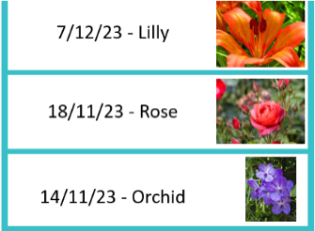Stack – A stack is a Last-In-First-Out (LIFO) data structure, meaning the most recently added item is the first one to be removed. A stack could be useful for visualizing searches of plants in **chronological order**. A stack naturally organizes items in the order they were added. This makes it perfect for visualizing searches from earliest to most recent, with the most recent search displayed at the top. This is shown by the image to the right.

Furthermore, a stack offers **real-time updates**, meaning, As users perform new searches, the stack updates in real-time, reflecting the most recent searches immediately. However, while a stack is great for visualizing the most recent searches, it's not ideal for accessing older searches without losing the more recent ones. This is because in order to access older searches using a stack, the stack has to remove items from the top one by one. This means the user can no longer view the most recent searches in the process.

**Validation**

* The compatibility of the picture file format with the AI system is crucial for successful interaction. The AI's capability to interpret the image relies on the specific file format it supports. This requirement varies depending on the AI being used. For instance, some AI systems may only recognize JPEG (JPG) files while others might accommodate different formats. Therefore, it's imperative to ensure that the picture files are saved in the correct format, adhering to the AI's specifications. In this context, using Portable Network Graphic (PNG) files instead of JPG could potentially result in compatibility issues, rendering the images unreadable by the AI.

## Identifying objects and classes

|  |  |  |
| --- | --- | --- |
| Type | Name | Description |
| Classes | PlantFinder | This is where the window will be created for the app, this will include all GUI aspects for the main structure of the app. |
|  | Login | This will contain all the code used when logging in, this will include checking the users details against a database of log in details |
|  | Signup | This will contain all the code used for users to create a new account, and saving it to a database, which will then be checked in other parts of the code. |
|  | SecondProgram | This is where the code for the second part of my program will be. In this class the image analysis will be made, and all further details will be illustrated here |
|  | UploadHandler | In this class the code for the server where the user will upload their image will be written. |
| Methods | init | Initializes objects and attributes within each class. |
|  | run(self) | Starts the main loop of the Tkinter application. |
|  | signin | Validates user credentials during login. |
|  | signup_cmd | Initiates the signup process. |
|  | signup | Validates user input and adds new users to the system. |
|  | on_enter | Handles behaviour when an entry widget gains focus. |
|  | on_leave | Handles behaviour when an entry widget loses focus. |
|  | exit_program | Exits the second program window. |
|  | upload_image | Initiates the image upload process. |
|  | show | Displays the upload handler. |
| Objects | root | Main application window. |
|  | login_frame | Frame for login interface. |
|  | img | Image for display. |
|  | frame | Frame for layout. |
|  | Heading | Label for headings. |
|  | Uname Pword | Entry widgets for username and password input. |
|  | Uname_label Pword_label | Labels for input fields. |
|  | Uname_entry Pword_entry | Entry widgets for user input. |
|  | signup_button signin_button exit_button upload_button | Buttons for actions. |
|  | ref_image | Reference image for analysis. |
|  | input_image | Input image for analysis. |
|  | output_text | Text widget for displaying output. |
|  | app | Tornado web application. |
|  | files | Uploaded files data. |
|  | img_dir | Directory path for uploaded images. |
|  | uploaded_image_path | Path to uploaded image file. |
|  | fh | File handle for writing uploaded image file. |
|  | error | Error value calculated during image comparison. |

## Test Data

In this section, I will lay out a test plan and test data for each of the sections of code I will test. All of the sections I will test will follow these plans and will use data mentioned in the test data.

|  |  |  |  |
| --- | --- | --- | --- |
| Data Item | Data Type | Validation/Restrictions | Input/Output |
| Picture | Image | * Required * Picture only, no background images | Input |
| Picture | Image | //////////////////////////// | Output |
| Information | Text | //////////////////////////// | Output |
| Username | Text | * Required * Letters and characters | Input |
| Password | Text | * Required * Letters and characters | Input |

## Robustness of solution

|  |  |
| --- | --- |
| Type | Description |
| Normal Data – the data that the program should expect, for example when prompted for a username, the data that the user enters should be accepted | Username, password and confirm password, email address should all be accepted by the system assuming they are all filled in correctly |
|  | User input image is in JPG format |
|  |  |
| Erroneous Data – this type of data should be rejected by the program, for example the username field is left blank | Username, password and confirm password, email address fields are all left blank |
|  | Confirm password is left blank |
|  | Password and confirm password do not match |
|  | Email address is left blank |
|  | User input image has background noise (will be rejected) |
|  | User input image is in PNG file format |
|  |  |
| Boundary Data – the maximum about of data that can be taken without the program breaking, this data will still be accepted but there is a fine line between acceptance and rejection | User input image has background noise, but it is blurred or barely visible |

## Test Plans

### Login Page

|  |  |  |  |
| --- | --- | --- | --- |
| Test ID | Description | Data | Expected result |
| 01 | Checking if the user can log in with correct data | Username = admin  Password = 1234  Login button pressed | * User is taken to the homepage |
| 02 | Check if error message is displayed when 1 or more fields are incorrect | Username = asdasd Password = asdasd  Login button pressed | * Error message is displayed |
| 03 | Checking if error message is displayed when password is incorrect | Username = admin Password = 12355  Login button pressed | * Error message is displayed * Password box is reset |
| 04 | Checking if error message is displayed when username is incorrect | Username = asdasd Password = 1234  Login button pressed | * Error message is displayed * Username box is reset |
| 05 | Checking if user is directed to sign up page when button is pressed | Sign up button pressed | * User is taken to the sign-up page |

### Sign-up Page

|  |  |  |  |
| --- | --- | --- | --- |
| Test ID | Description | Data | Expected result |
| 01 | Checking if the user can create a new account | Username = easa  Password = 1234  Sign up button pressed | * User is taken to the homepage |
| 02 | Check if error message is displayed when password do not match | Username = easa  Password 1 = asdasd  Password 2 = asd  Sign up button pressed | * Error message is displayed * Password box is reset |
| 03 | Check if the user already has an account that they are taken to another page | Sign in button pressed | * User is taken­­­ to the log in page |

### Image upload server

|  |  |  |  |
| --- | --- | --- | --- |
| Test ID | Description | Data | Expected result |
| 01 | Checking if the program creates the local server | N/A | * Website is loaded |
| 02 | Check if website is able to have images uploaded to it | Choose File button is pressed  Image.png  Upload button pressed | * Images are saved to the “img” folder |
| 03 | Checking if hover-able information is showed | Mouse input | * Informative text is showed when mini “i” is hovered over |
| 04 | Check if website is displayed properly | clearlogo.png | * Background image is the logo |
| 05 | Checking if the program opens the website automatically | Index.html | * Website will open up automatically |
| 06 | Check to see that the program automatically closes after 30 seconds of inactivity | No mouse input or file uploaded | * Website will close automatically, and users will be greeted with the homepage again |

### Reverse image searching

|  |  |  |  |
| --- | --- | --- | --- |
| Test ID | Description | Data | Expected result |
| 01 | Checking if the program is able to identify an image | Image in database | * Program outputs the name of the image |

### Image comparison

|  |  |  |  |
| --- | --- | --- | --- |
| Test ID | Description | Data | Expected result |
| 01 | Checking if the program can compare 2 images of the same format | Rayyan1.jpg  Rose1.jpg | * MSE value is outputted |
| 02 | Checking if the program can compare 2 images of different format | Rayyan1.jpg  Rose1.png | * Error message is displayed telling the user that the image uploaded won’t work |
| 03 | Check if images are converted to greyscale | Rayyan1.jpg | * Program will continue and provide a MSE value |
| 04 | Check if the image comparison is able to compare user uploaded image and all images in the database | User-uploaded image  Images in “img” folder | * Program outputs the MSE values for each comparison |
| 05 | Check if program is able to compare images in 2 different folders | “img”  “TestData” | * Program will continue and provide a MSE value |

### Automatic resizing

|  |  |  |  |
| --- | --- | --- | --- |
| Test ID | Description | Data | Expected result |
| 01 | Checking if the image uploaded to the program will be resized | Sunflower2.jpg | * Image is resized to 720 by 720 pixels |
| 02 | Check if program can work within the image comparison program | Sunflower2.jpg | * Program will continue and provide a MSE value |

### Output

|  |  |  |  |
| --- | --- | --- | --- |
| Test ID | Description | Data | Expected result |
| 01 | Checking if the program outputs the MSE values from the image comparison | Files in “img”  Files in “Database” | * MSE values will be outputted. |

### Post development plan

|  |  |  |  |
| --- | --- | --- | --- |
| Test ID | Description | Data | Expected result |
| 01 | Checking to see that the user can create an account successfully | Username = test1  Password = test1  Mouse button click | * Notification box should appear saying account made |
| 02 | Checking to see if error message will show when passwords are mismatched | Password = test1  Password = test2  Mouse button click | * Error box will show saying passwords are mismatched |
| 03 | Checking to see that the if the incorrect details are entered then the respective error message is entered | Username = test1  Password = test2  Mouse button click | * Error box will show saying that the username or password is incorrect |
| 04 | Checking to see after the user has logged in, pressed the upload button, the local server is loaded and opened | Mouse button click | * The program automatically opens up the website |
| 05 | Checking that the user is able to select a photo and upload it to the server | Sunflower3.jpg | * Program will move the image to the dedicated folder |

# Implementation

## Log in Function

Below are the imported libraries used in this section of the program. The tkinter library is a GUI toolkit for Python. The first line, from tkinter import *, imports all classes, functions, and constants from the tkinter module, allowing for convenient access to its components. The second line, from tkinter import messagebox, specifically imports the messagebox module from tkinter, which enables the creation and display of message boxes for user interaction. Lastly, the line import ast imports the built-in ast module, which facilitates the parsing of Python code into abstract syntax trees.

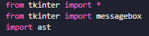

In the below code, the signin() function in this handles user authentication by retrieving the entered username and password from the user and pword variables respectively. It then opens a file named "login_details.txt" in read mode, reads its contents into the variable d, and evaluates it using ast.literal_eval(). After closing the file, it checks if the entered username exists as a key in the dictionary (username in r.keys()) and if the corresponding password matches the one entered by the user (password==r[username]). If the credentials match, it opens a new window using Toplevel() from tkinter to display a welcome message, which is a place holder for the home screen GUI that will be made later. If the credentials are invalid, it displays an error message using messagebox.showerror() indicating that the username or password is incorrect.

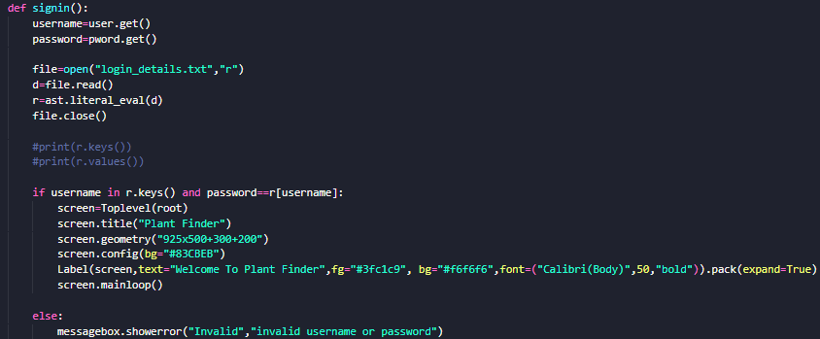

The code below handle placeholder text in Tkinter entry widgets for username and password fields. They define functions on_enter() and on_leave() to manage the placeholder text behaviour when the widgets gain or lose focus. When focused, the default text is cleared, and when unfocused and empty, the default text is restored. Horizontal lines are also drawn beneath each widget for visual separation.

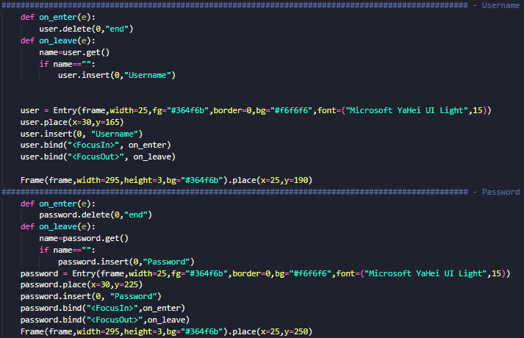

### Testing Login Function

Test ID – 01

Description: Testing successful log in, for admin users when all fields are filled in correctly(Correct username and password)

Test Data: Username = admin, Password = 1234

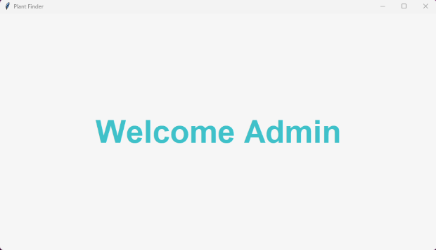Output:

Test ID – 02

Description: Testing logging in, when 1 or more fields are incorrect

Test Data: Username = asdasd, Password = asdasd

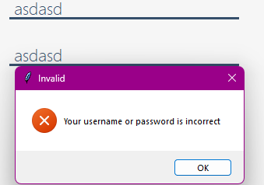Output:

Test ID – 03

Description: Testing authentication where only the password is incorrect

Test Data: Username = admin, Password = 12355

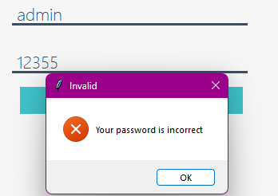Output:

Test ID – 04

Description: Testing authentication when only the username is incorrect

Test Data: Username = asdasd, Password = 1234

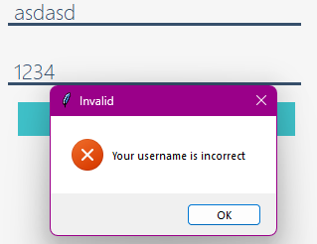Output:

### Feedback from client

So far, my clients have said that they liked the design of the log in screen, but they would have liked the password field not visible to everyone, so I have changed the code so that is no longer the case.

Before

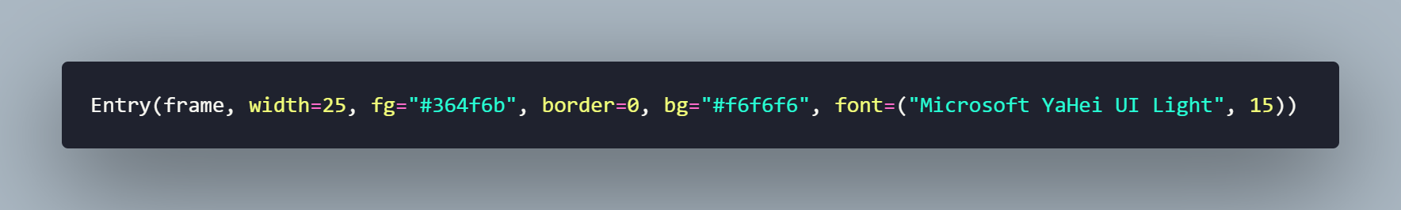

After:



After testing and making appropriate changes, and testing again, this function of the code works as intended, with all tests from the test plan giving the expected result. When details are entered successfully and the log in button is pressed the user is taken to the homepage, the appropriate error messages are shown when the relevant issue occurs, and the user is taken to then signup page once pressing the sign-up button.

## Sign up Function

In the code below the signup_cmd() function is responsible for creating a signup window for the application using the Tkinter library. When invoked, it opens a new window (Toplevel()) titled "Sign Up to Plant Finder" with specified dimensions and styling. Inside this window, it defines nested functions signup() and sign() for handling the signup process and window destruction respectively. This function retrieves the username, password, and confirmation password entered by the user. It then checks if the password and confirmation password match. If they do, it attempts to open a file named "login_details.txt" and updates it with the new username and password. If the file doesn't exist, it creates it and writes the username and password. If there's any error during this process, it catches the exception. The sign() function simply closes the signup window. Additionally, it displays my logo and constructs a frame within the window to organize the signup form elements aesthetically.

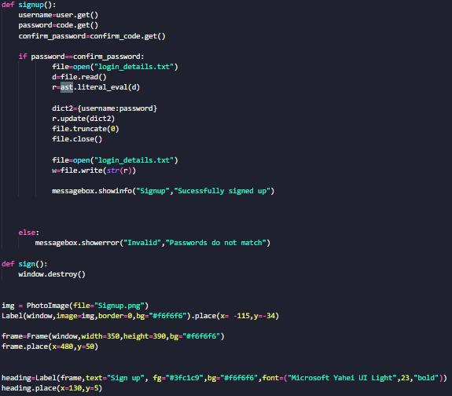

Similarly to the log in function, the program will get the username and password, and this time the confirm password from elsewhere in the program. The code below is for confirm password, as the code for self.uname and password is the same as previous code.

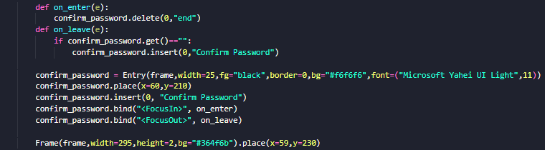

If the user has accidentally clicked on the sign-up button created in the Log in page, they will need a way to navigate back to the Log in page, therefore I have created a way to do so, which is show in the program below, which just closes the current window and open up the sign in page.

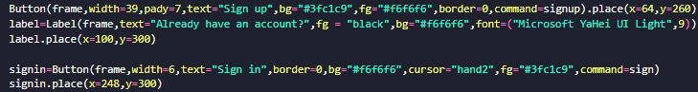

### Testing Signing up Function

Test ID – 01.0

Description: Testing the creation of new accounts, and testing if they correctly save into a dedicated file, if this doesn’t exist then the program should create a file

Test Data: Username = easa, Password = 123

Output Before:



Fix: After doing research, the reason for the error is because I can’t truncate a file opened in read mode, which is how the file is opening by default. And therefore, I need to change this.

Code After:

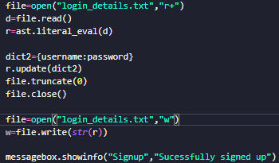

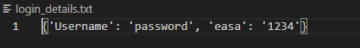Output:

Test ID – 01.1

The previous test assumed that the database already exists, I will be removing it for this test so see if the program detects that there is no file already and seeing if it creates one.

Test Data:



Output Before:



Fix: I had wrongfully assumed that the program will automatically create the database file if it is not found, I need to be specific and state that if the file is not found, then it must be created

Code After:

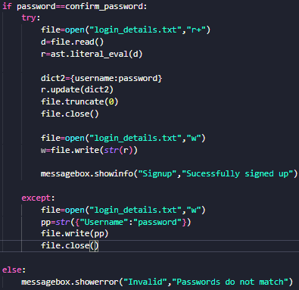

Output After:



Test ID – 02

Description: Testing creating an account where the passwords do not match

Test Data: Username = asdasd, Passwords = asda and asd

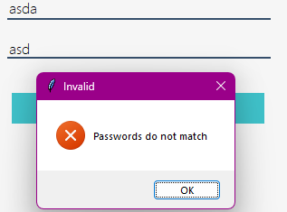Output:

After testing, the sign-up page effectively creates new accounts, saves them to the database, and displays all relevant errors. For instance, if the password and confirm password fields do not match, the appropriate error message is shown. Additionally, clicking the sign-in button successfully navigates the user back to the sign-in page.

## Image upload server

In this section, the program initiates by calling upon "index.html," which contains all the aesthetics for the website and the website itself. Acting as the gateway for users, the website allows them to upload their images and have them saved to the program. Additionally, within this section of the code, the folder "img" is created if it does not already exist; this is where the user-uploaded images will be stored.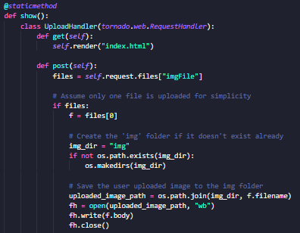

In the code below, the code should demonstrate the automatic opening of the website (in actual fact the website won’t open automatically when starting the program but when clicked on when the rest of the program is finished) however for testing purposes it is isolated and should open automatically when the program is run.

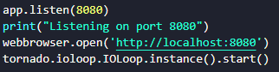

In the code below, I have implemented an automatic stopping of the local server and consequently the automatic closing of the website feature so that the user won’t have to worry about manually closing the website. Text will be displayed to tell the user that the server and website is stopping and closing down.

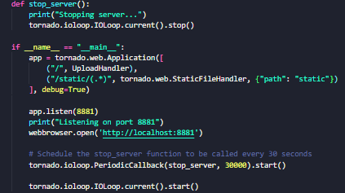

In the code below, I have implemented a quality-of-life feature for the user. The program requires JPG format files, and if the user does not know this, then they should be able to hover the “i” and receive information.

I want my logo to be on my website, firstly so that the user is assured that the website is still part of my program, and secondly it is something to fill the empty website, this should be done in HTML by the code shown below.



### Testing Image Upload Server Function

Test ID - 01

Description: Validating the creation and availability of the local port during the program execution, coupled with verifying the successful automatic startup of the website.

Test Data: N/A

Output before: When the program is run, the code creates a website that is opened automatically, however there was a problem with the port, as shown in the picture below, it says the site cannot be reached, reading into the error more it says the “local host refused to connect.”

Code Before:

Fix: This error occurred because the local port(8080) was being used for something else, **this could be user specific**, but I have changed the local port to use port 8881, for the benefit of myself and other users that have port 8080 in use.

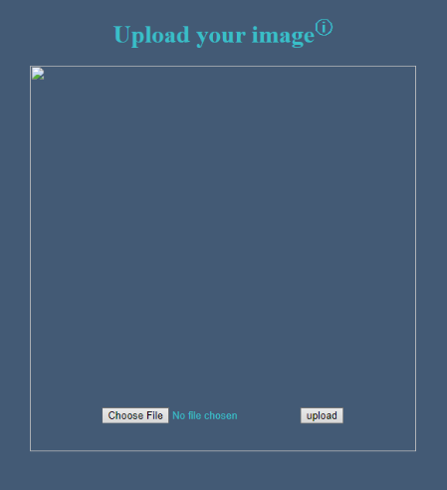Output after:

Code after:

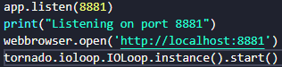

Test ID – 02

Description: Testing the programs ability to handle files being uploaded to it and have them save to a dedicated folder.

Test Data: *image.png*

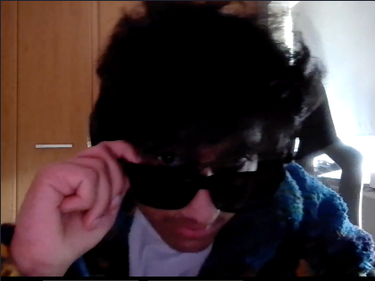

Image.png

Output before: Once uploaded to server, the picture wouldn’t show in the dedicated folder

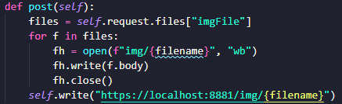Code before:

Output Before:

**Note: If this test was successful there should be 3 images in the folder**

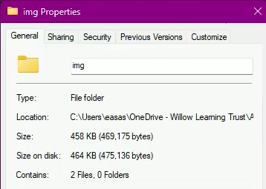

Fix: The code I had written before didn’t work properly, there were error-underlined on the filename, and I don’t think that the code was able to transfer the image from the server to the dedicated folder. I did more research and found a way to fix this, shown in the changed code below.

Code after:

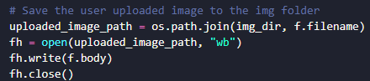

Output after:

Server acknowledges image:



Image now shows in designated folder:

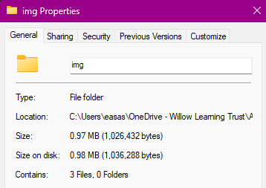

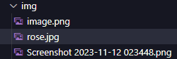

Test ID – 03

Description: Testing to see if the hover-able information sign appears when the user hovers over with their mouse

Test Data: Mouse input

Output before:

Code Before

Fix – More of a quality-of-life update for the user, changing the “i” to an actual information symbol can make it easier for the user to know how to use this feature.

Output after:

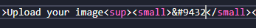Code after

Test ID – 04

Description: Testing to see that all aesthetic aspects of the website works.

Test Data: N/A

Output before: When the website loaded, my logo didn’t show when running via the program (using tornado – a pip package) but loaded when opening the HTML file directly.

Code before:



Fix – This error could have occurred because I wasn’t specific enough, even though the image is in the same directory as the html and the other program, so I changed it to be more specific.

Code after:

Output after: Nothing changed, and still the same problem occurred, where the website didn’t show my logo when being run through the program but did show when opening the HTML file directly.



Fix – After doing more research a static folder is needed for the image to be stored in, so I rewrote the code to make sure that the image was first stored in a static folder, and then I had to “tell” the program that it needs to use the static folder.

Code after:

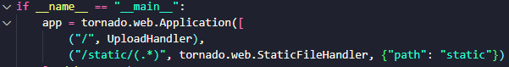



Output after:

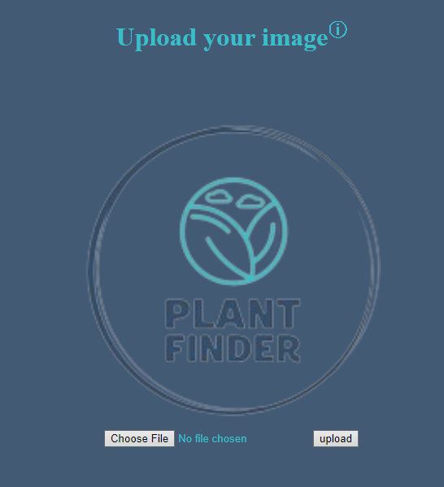

Test ID – 05

Description: Testing the website opening automatically

Output: <https://youtu.be/ZgeXVI2vXLs>

In the video I showcase the automatic opening of the program, for this example, I have kept the program separately from the main program for testing purposes and will combine the programs at a later date.

**Note – As of creating this video(30th Jan 2024), I had not yet fixed the image being static, since then I have fixed the issue, and this is present in test 04.**

After testing, this section is able to successfully open up the server automatically, have images save to the dedicated folder, and provide additional information to users in a friendly manor.

## Reverse image searching

In the code below, making use of the AI made by MobileNet which is already pre-trained on the ImageNet dataset. This model can classify images into 1000 different categories, meaning I don’t have to teach the AI to identify images. The program reads an image from the given image_path using OpenCV (cv2.imread()), it will then resize this image so that the parameters are in line with those of the AI, and then make a prediction on what the top 3 classes of identification the image is likely to be.

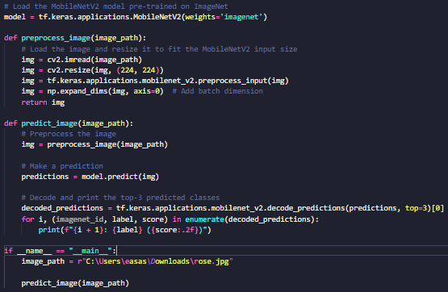

### Testing Reverse Image Searching Function

Test ID – 01

Description: Testing to see if the code works, this version of the code will only be able to take in one image from a dedicated path, this will be changed later so that it can use the user uploaded photo.

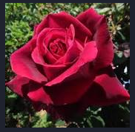Test Data:

Output Before: 

Fix – After doing research on the internet, I found that Tensor flow is no longer supported[10] and therefore a downgrade of python versions will be needed to fix the issue.

## Changes to implementation - justification

After conducting tests on reverse image searching and exploring related Python libraries, particularly focusing on Tensorflow, a challenge has arisen due to Google's decision to discontinue updates and support for the library. To address this, the proposed solution is to downgrade the Python version to a point where Tensorflow was still supported. However, this introduces a new problem – some of the newer libraries used in the program may not be compatible with older Python versions. Following the change in the method of implementation, certain features and aspects are subject to change. Due to time constraints and a lack of in-depth knowledge on potential solutions, finding a compromise that addresses both issues simultaneously proves difficult. Consequently, I have decided to proceed with the development and testing of a contingency plan (as mentioned previously). Although not as accurate as Tensorflow would have been, the incorporation of image comparison remains viable. The decision to implement my contingency plan is driven by the necessity to move forward despite the challenges.

It's worth noting that the decision to proceed with a contingency plan reflects a pragmatic and adaptive mindset, recognizing the importance of making progress within the given constraints. This approach allows for the continuation of development and testing while acknowledging and managing the limitations imposed by the software and time constraint

## Image comparison

For this section, I am testing the parameters of the program since this is a fairly new topic to me. There are 3 “playtests” that are going to be shown

In this snippet of code, I have specified the paths to where the program will retrieve the images. Before the comparison is made, for the benefit of the AI the images need to be converted to greyscale first, then the comparison can be made, after this is done the program should output the MSE values for them if everything is successful. **This section of code compares 2 images when they are specified**

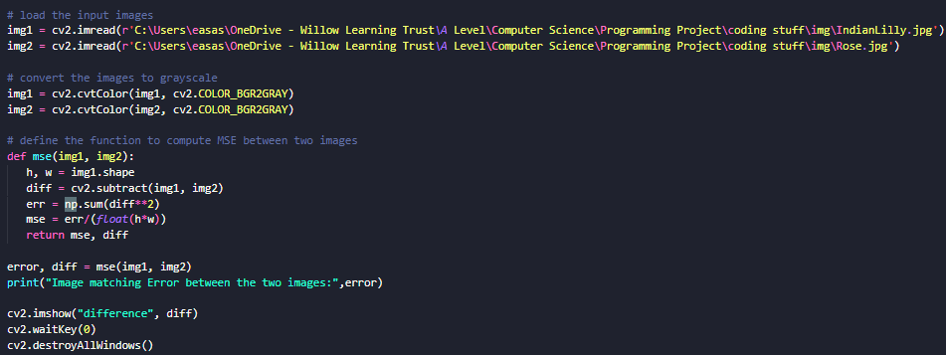

In this section the program will go through the files in the folder with the format JPG, and for all those that don’t then the output “Don’t work” will be presented to the user telling them that the image they uploaded doesn’t work. Also, the program will attempt to firstly convert all images into greyscale first and then compare them all to a reference image. This is different from the code above, as in the code above the 2 images are provided, whereas in the code below, only one image is provided, the rest must be fetched from the folder. **This section of code compares one image in a file and one image path specified, (this will simulate the user uploaded image).**

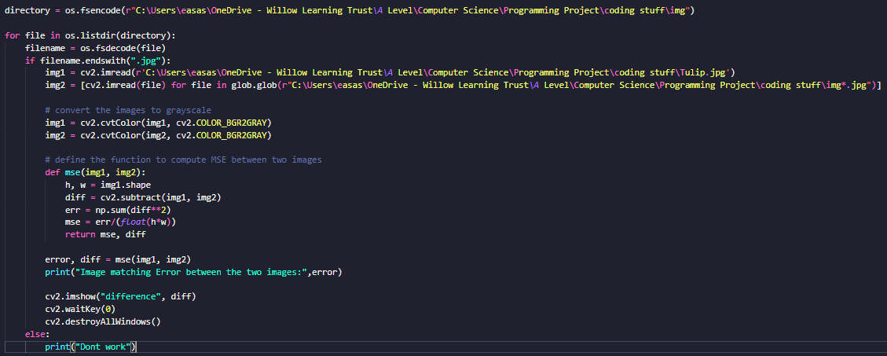

### Testing Image Comparison Function

Test ID – 01

Description: First test of image comparison, testing the program when comparing between 2 different images. **(This uses the first snippet of code)**

Test Data:

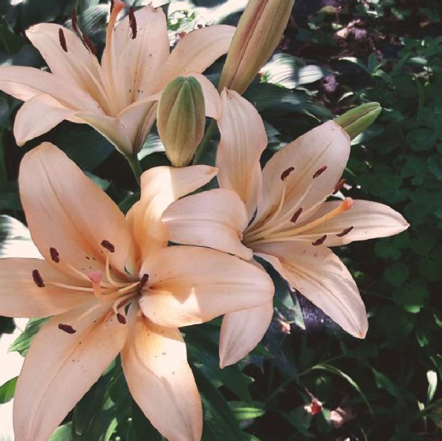 

Rose2.jpg

Output Before:



Explanation – This test was an anomaly the MSE value should not be this high, this was because the image quality was low, and the resolution was small – 720 by 720 pixels, a larger sample will require additional storage for the user and will increase the minimum hardware requirements.

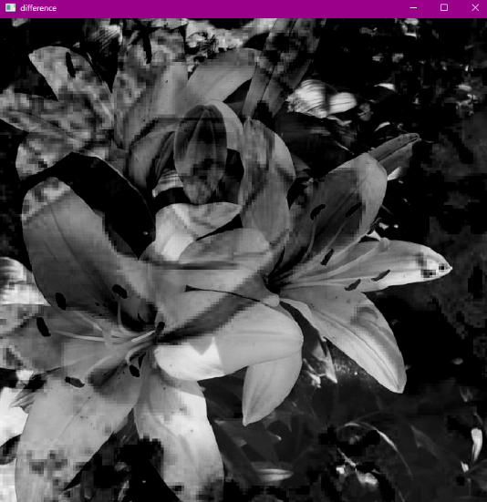This is what the Test ID 01 looks like, and this is what the AI uses to compare the two images, it converts them to black and white and plots certain *key points* that it will use to identify features of the other image. Whatever photo is put first(in the finished program it will be the user input) will be used to create the *key points.*

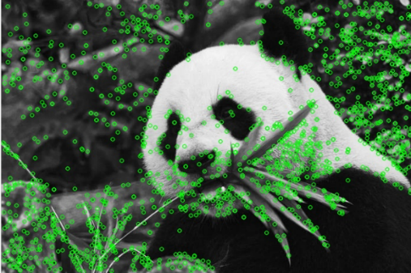For example, in this image all the green dots are used as *key points,* which will be used to compare against another image.

Test ID – 02:

Description: Testing comparing user input (file in downloads for now) to all files in the “img” folder, going through each file, converting to greyscale, and then comparing and using the MSE equation. **(This uses the second snippet of code)**

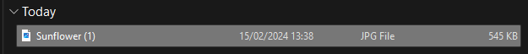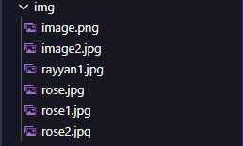Test Data:

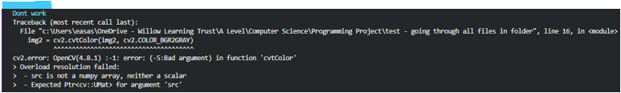Output Before:

Explanation – the highlighted piece of code(in blue) states that for all jpg images in the folder to do the function of converting to greyscale, and using the MSE equation, but for all other files such as the PNG file (image.png) the output - *Don’t work* will be output, and this part was successful as shown by the output highlighted in blue, and when converting the images, as the AI only deals with JPG format files, since there was a PNG image, it didn’t convert all the photos, and therefore the error message was output. This error has now been fixed and the PNG image will be removed

Test ID – 03:

Description: Testing another way of trying to compare multiple images with one user input, I have broken down the problem into 2 different sections, one being to first convert the images into greyscale which must be done before any images can be compared, and secondly comparing each of those new greyscale images with the user image. In this test I am testing converting all the images in the folder(img) to greyscale first.

Test data:

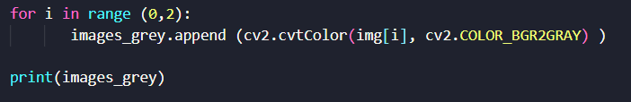Code Before:

Output Before:

Fix – receiving the error “list index out of range” I decided to try another method of going through all files in the folder “img”, using a while loop in this iteration of the code.

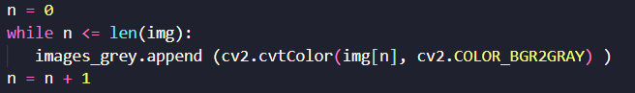Code Before:

Output Before:

Device crashed – reason is because of an infinite while loop.

Fix – went back to the for loop and did more research and found out that the problem was because there is a non-jpg (the same type of error as in test 03) file in the folder and therefore it shouldn’t count as part of the list.

Code After:

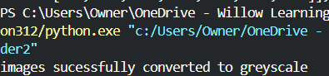Output after:

Test ID – 04:

Description: Once successfully converting all the jpg file format images into greyscale, testing begins on comparing all the images converted, against another photo, providing an MSE value for each

Test Data: N/A

Code Before:

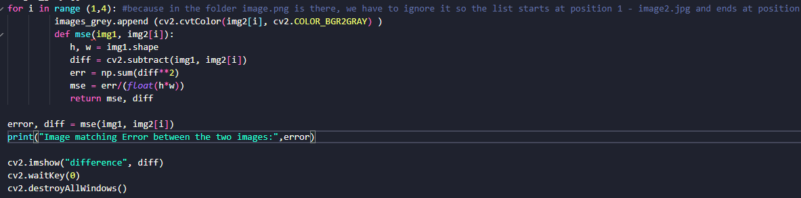

Output Before:



Fix: changed img2[i] to the name of the list

Code Before:

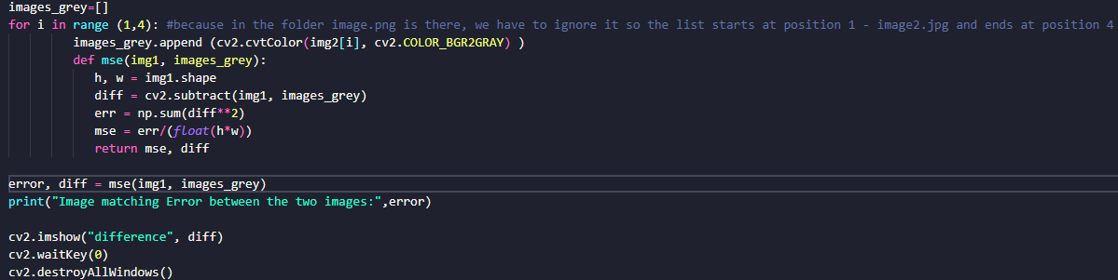

Output Before:

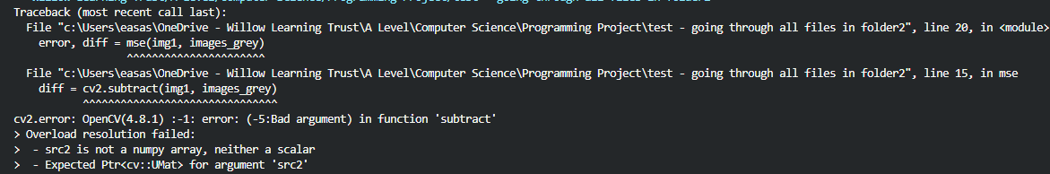

Fix: Error message was saying the error was in the line of code diff = cv2.subtract(img1, images_grey), this may be because it can’t compare between img1 and a list

Code Before:

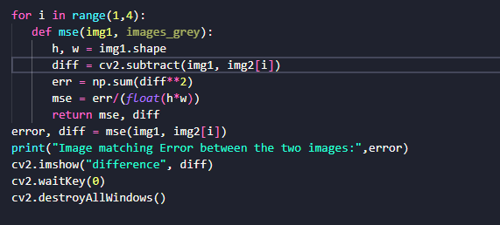

Output Before:

cv2.error: OpenCV(4.8.1) D:\a\opencv-python\opencv-python\opencv\modules\core\src\arithm.cpp:650: error: (-209:Sizes of input arguments do not match) The operation is neither 'array op array' (where arrays have the same size and the same number of channels), nor 'array op scalar', nor 'scalar op array' in function 'cv::arithm_op'

Fix: The error says that the images are not the same size, I will have to delete all other images in the folder apart from the images I am testing.

Changed Data:

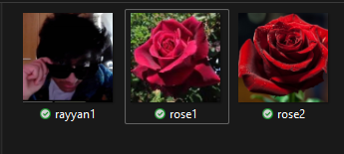

Code Before:

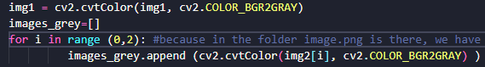

Output Before:



Fix: scrapped the program and started again, decided to not use the “glob” python library, restructured how the program takes in files and then converts them into greyscale, and how the program compares each of the items in the *database* to the file that the user will upload

Code After:

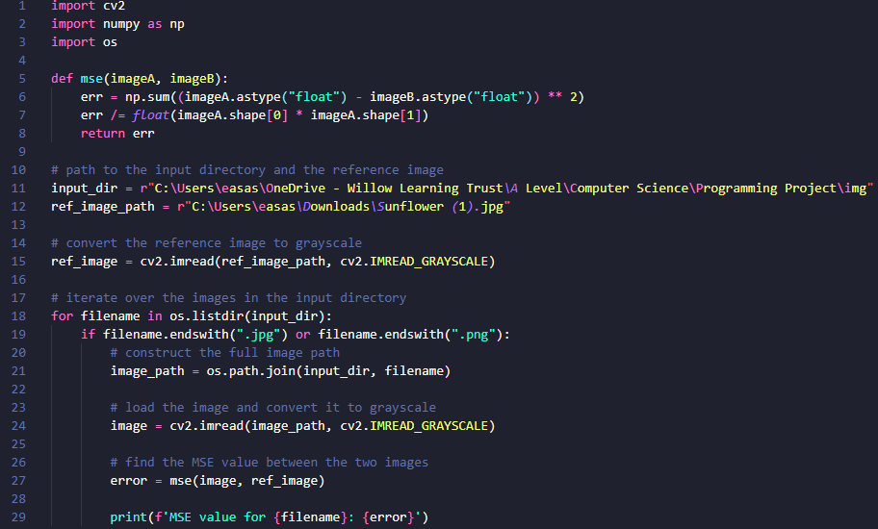

Output After:

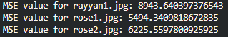

New Test Data:

 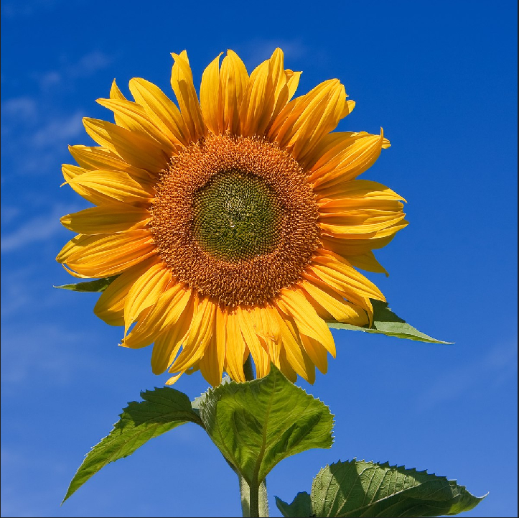

All files were low quality, and image sizes were still 720 by 720 pixels which is why rayyan1.jpg and sunflower1.jpg showed as the highest match.

Test ID – 05:

Description – When testing the program that goes through all files in the dedicated folder, and when testing comparing 2 images, I noticed that I got different results, the MSE values were drastically different.

Test Data: N/A

Code Before:

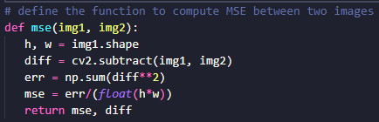

Output Before

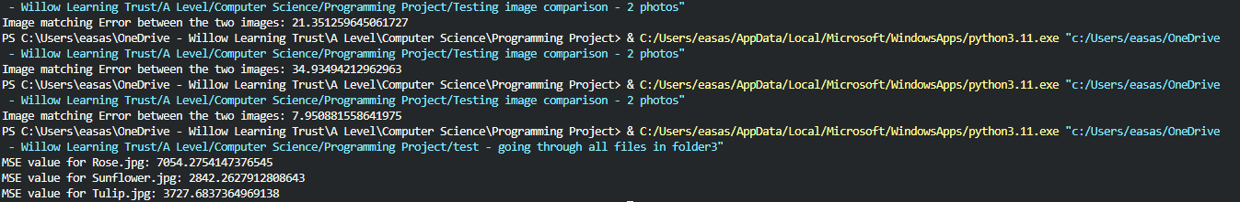

Fix: This was because the calculations for the MSE values were different, and therefore provided me with different results even though the test data was the same, I will need to change the calculations to be the same and test again.

Code After:

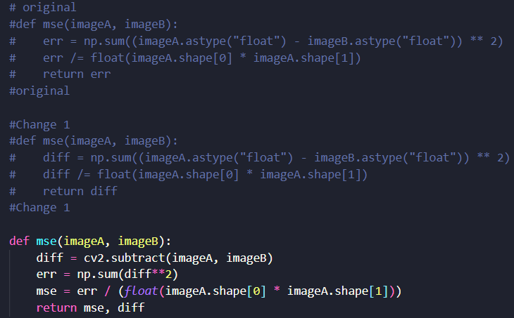

Output After:

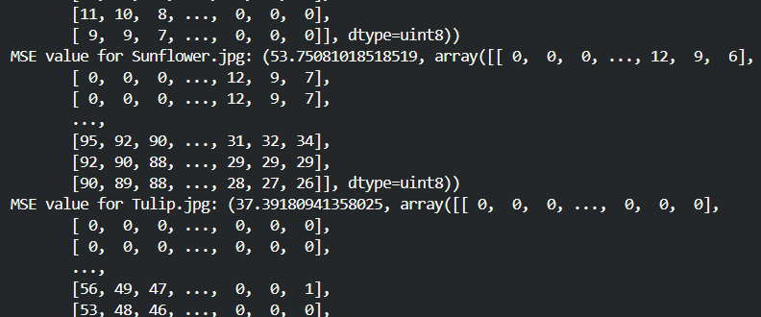

Fix: The output is now showing answers consistent with the rest of the program, I need it to not show the table after and only provide the values

Code After:

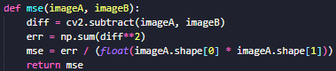

Output After:

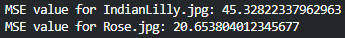

Explanation – Now that all the code is fully functional, testing has begun again, and the program is now providing correct results, and as shown in the output, when comparing one image against multiple images we now see how when comparing “testdata indianlilly2” against the images in the makeshift database “img” gives us “correct” MSE values, or values that make sense as the pictures of Indian lilies should look the most similar.

After testing, this section of the program is now successfully able to take images from a direct source and compare them against files in a database, simulating what the actual program will function like. This then provides the user with MSE values for each comparison done.

## Database Creation

Before: After:

 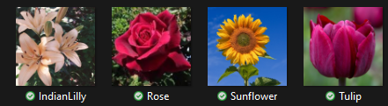

**Notes**: The database will continue to grow as I add more flowers and resize them

## Automatic resizing

Not all images that user has to upload will be the correct size for the AI to use, and therefore I made another quality-of-life section of code that will automatically stretch or shrink the image so that it fits the 720 by 720-pixel size.

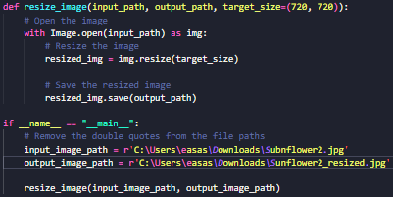

### Testing Automatic resizing Function

Test ID – 01

Description: Not all images that the user uploads will be the same size, and this will cause problems as the image comparison aspect requires all images to be the same size, therefore I have chosen the size 720by 720 pixels which allows for the clearest presentation of the image whilst saving space compared to a larger size and still providing accurate results.

Test Data:

"C:\Users\easas\Downloads\Sunflower2.jpg"

Output:



**Notes**: In order for the program to be able to resize the input image, the output image has to be the same name, as shown in the image below



Explanation - the output path “Sunflower2_resized.jpg” has to be changed manually, which won’t solve what the programs’ purpose is, and therefore I will just scrap the program, as its use cannot be justified, and instead at the inconvenience of the user, they will just have to upload the image already in the size 720 by 720 pixels.

## Output

To enable users to access program results seamlessly, I've developed a code snippet that presents Mean Squared Error (MSE) values for all image comparisons. The program conducts image comparisons, including grayscale conversion, and generates a new window to display the MSE values.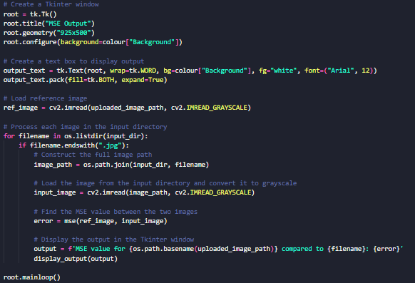

### Testing Output Function

Test ID – 01:

Description: Testing the final output, which is where the user will see all the comparisons made between the image that they uploaded and all the files in the database.

Test Data:

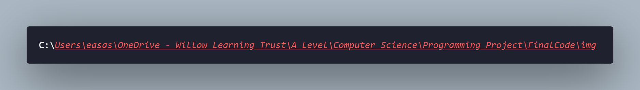

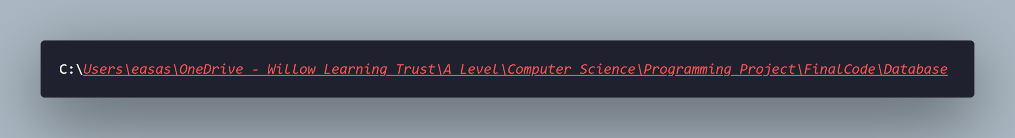

Output:

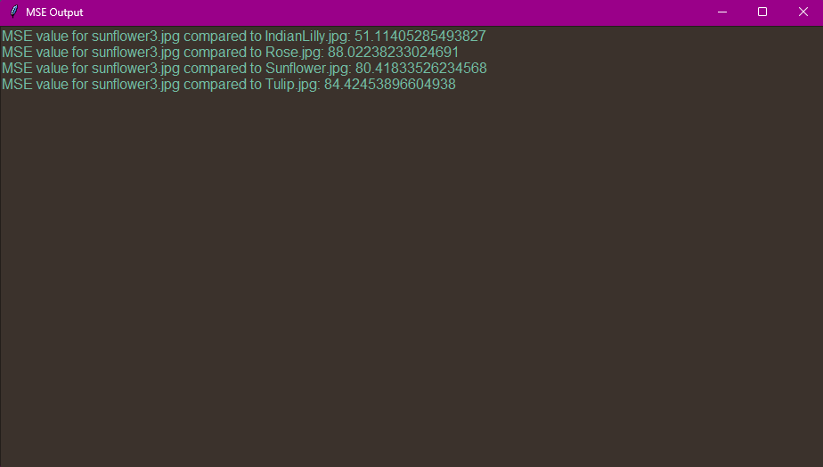

## Homepage

Test ID – 01

Description: Testing how the homepage looks and if all the functions are displayed properly, for example the buttons are in the correct place and if the text is readable

Test Data: N/A

Output:

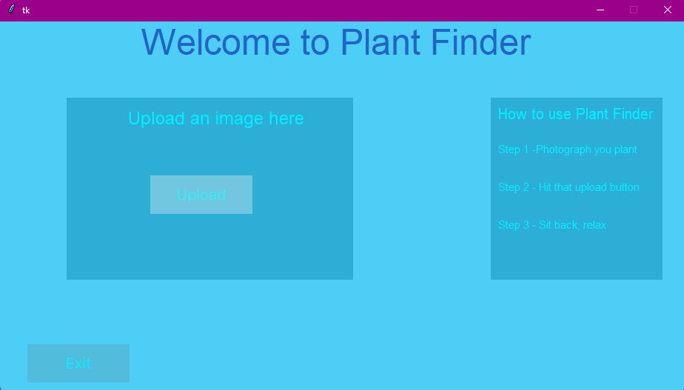

Idea:

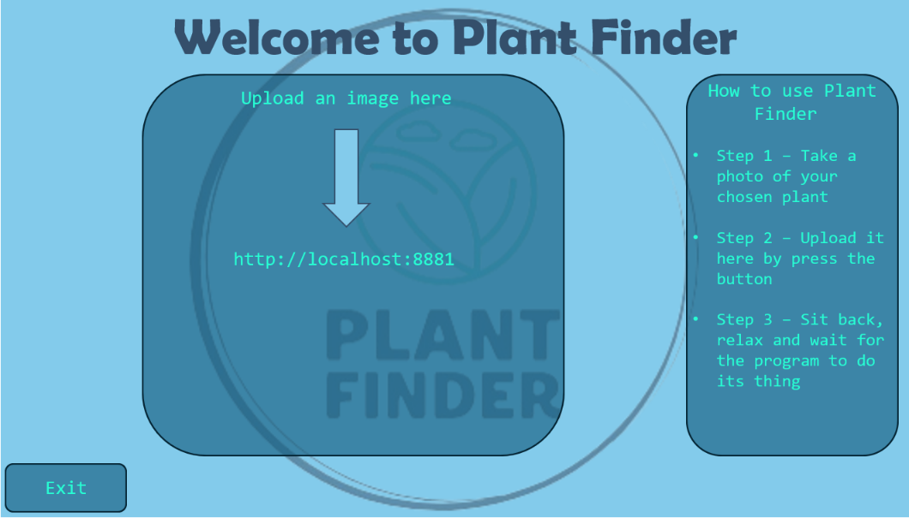

**Notes**: Due to some limitations of Tkinter, some compromises had to be made in order for the home screen to be fully functional and contain all the information needed. For example, the directions on how to use Plant Finder, had to be shortened, the boxes couldn’t not be rounded, and the logo could not be displayed behind the boxes.

## How Login/Sign up links with the Homepage

When the user starts up the program, they will be greeted with the option to sign in(to an existing account) or be prompted to create an account.

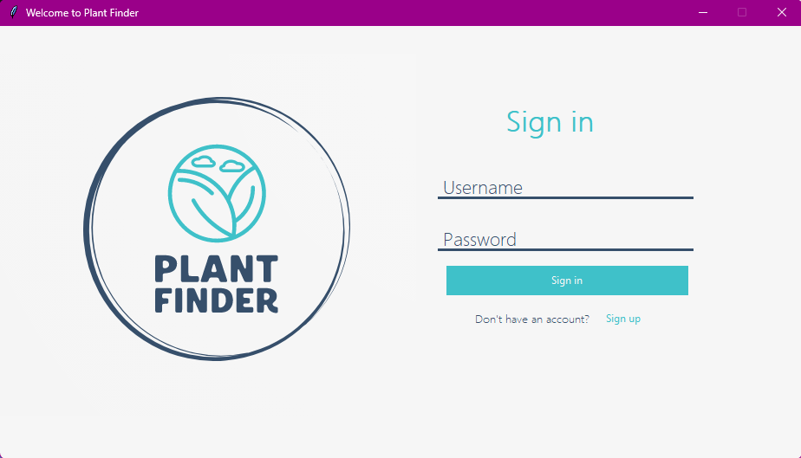

If they choose to create an account by pressing the Sign-up button, they will be brought to a separate window where the user can then create an account.

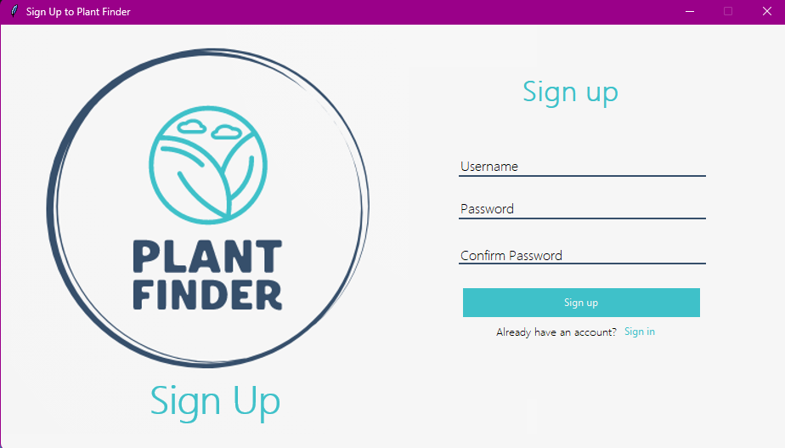

Once the user has logged in/made an account, they will be greeted with the new home screen which gives the user the option to upload an image, by pressing the “Upload” button, or to exit by pressing the “Exit” button.

Before: After:

 

## Overall feedback and changes made

From one of my stakeholders, when showing them my program, they said that so far, the program works as intended, and includes all the features they want. The only comment that was said was that the with the introduction of the new home screen, the colours are too similar(this stakeholder is colour blind(Tritanomaly)), and said that it was hard to read the “How to use steps”

Their Point Of View*(POV): Normal POV:

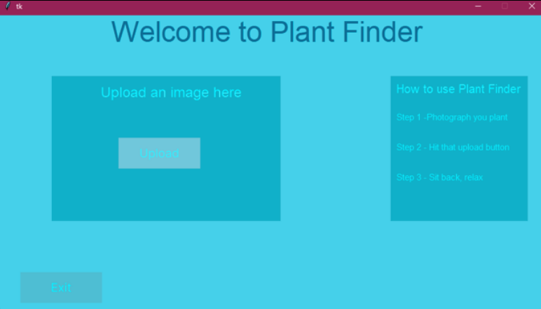 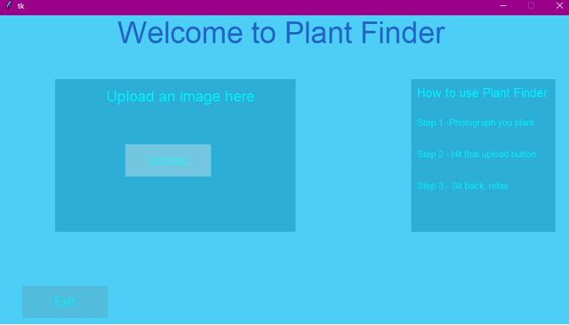

To accommodate for this, I have changed the colour pallet to make the text accessible to all, without sacrificing any looks and still providing all information needed.

New POV: New POV(with Tritanomaly):

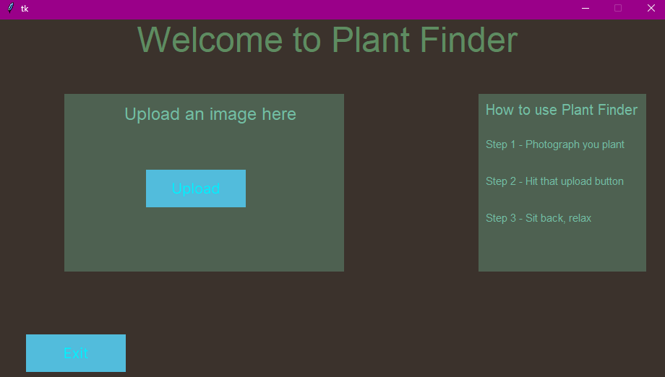 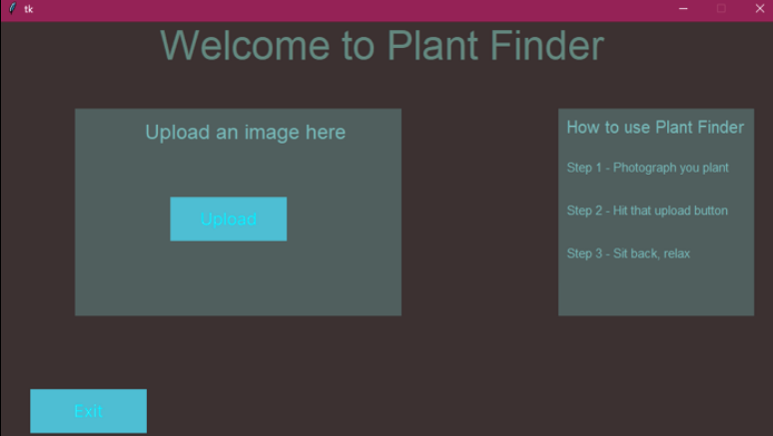

When showing another client, the design and colour scheme they said that the colours are a bit dull and maybe it would be hard to use in dark environments. So, I have changed the colour scheme again to make it more accessible in dark environments.

*not a fully accurate representation of how they see

New POV: New POV(with Tritanomaly):

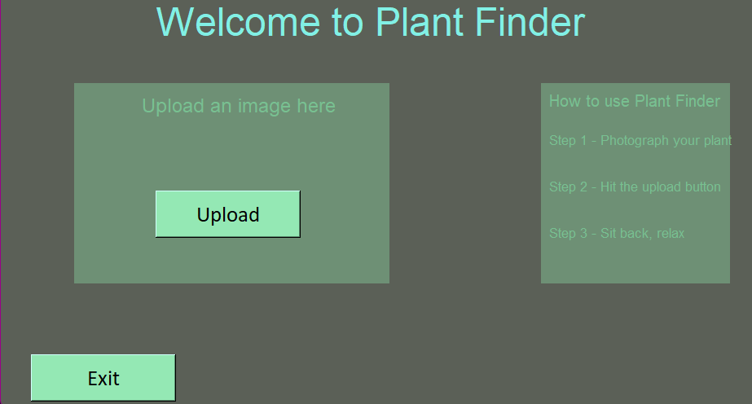 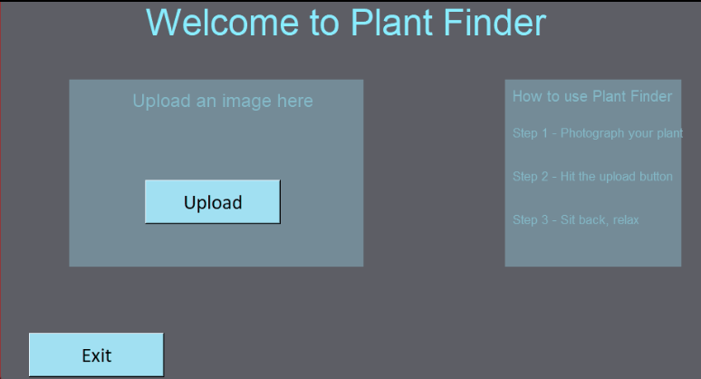

# Evaluation

## Testing to inform evaluation

### Video Showcase

In the video below, I demonstrate the program in its full capacity, showing the creation of a new account, to uploading an image, and getting a result. In the video here, the respective error messages are shown. This links to my post development test plan (Post development plan), where all the tests conducted are reflected in the video.

<https://youtu.be/FE2caMqlIG4>

## Post development

### All libraries used

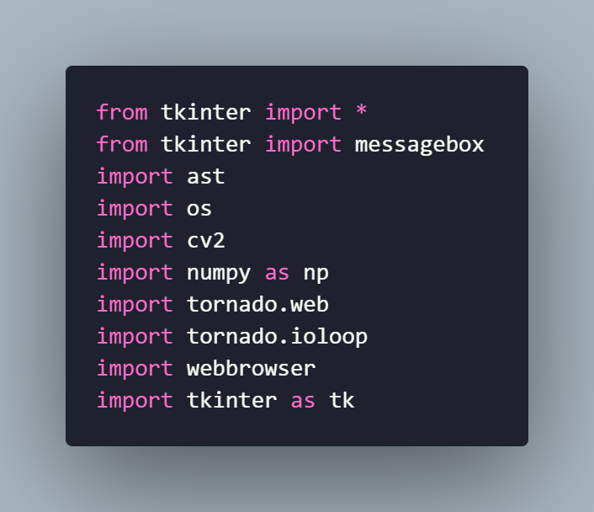

### Logging in function

From video, timestamp: 0:55 – 1:06

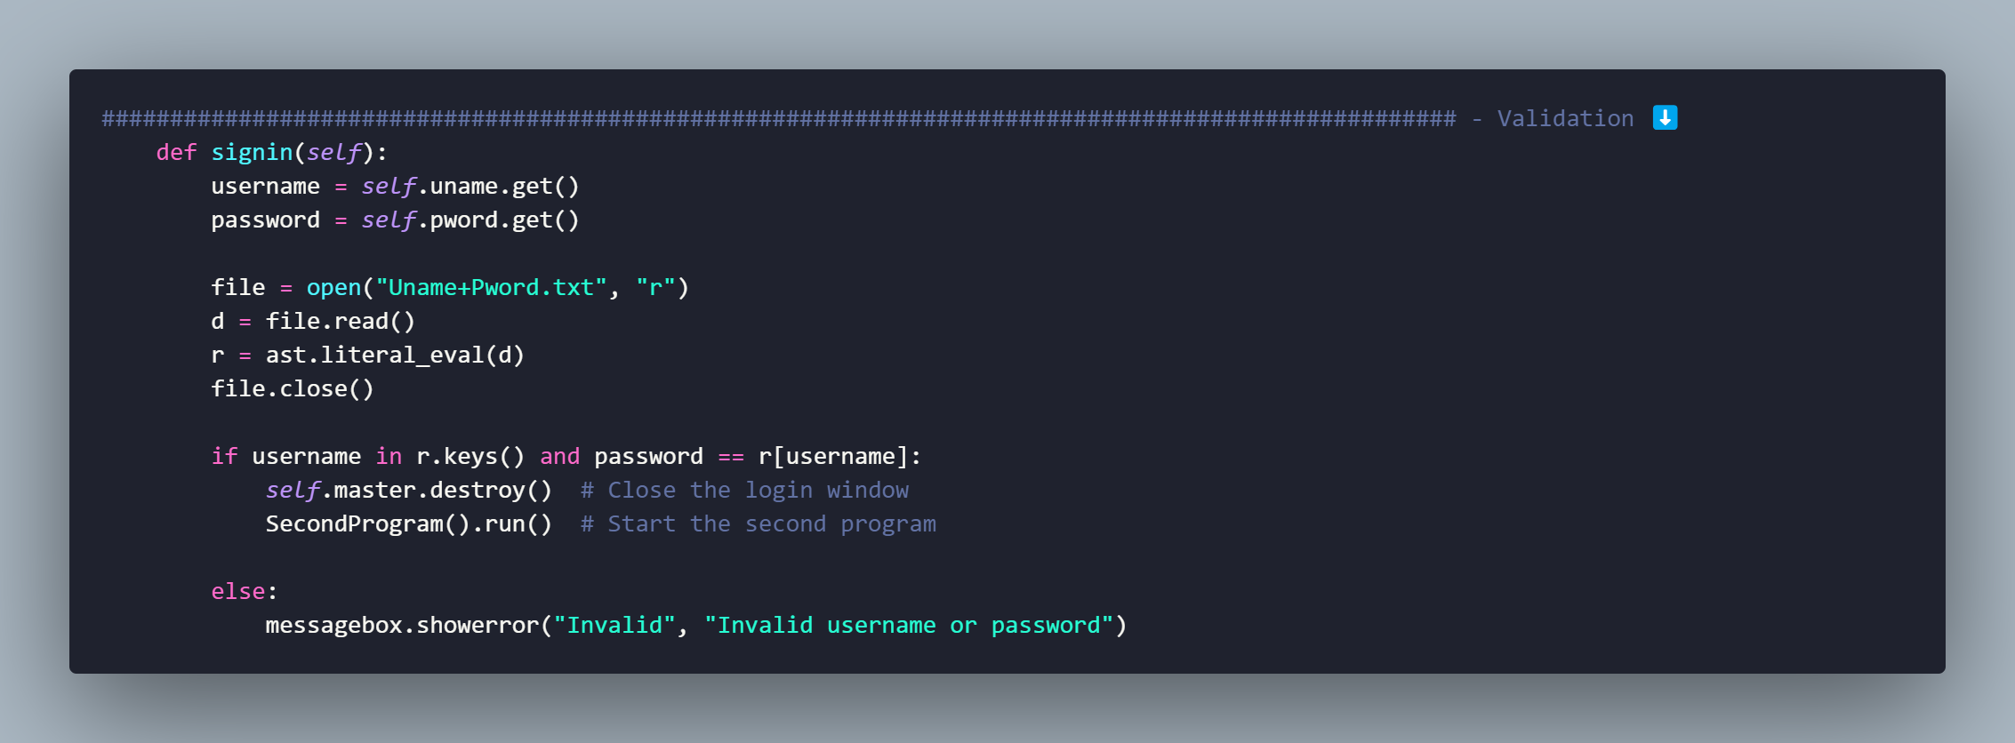

In this section of code, the program asks the user to enter their username or password. The code calls upon two functions: uname.get() and pword.get() to verify the username and password entered. This is checked against the same database where new account details are inputted. If there is a valid username and password, that matchers with the details the user entered, then the code will move onto the next section, if not an error message box will be displayed.

### Signing up and validation

From video, timestamp: 0:00 – 0:35

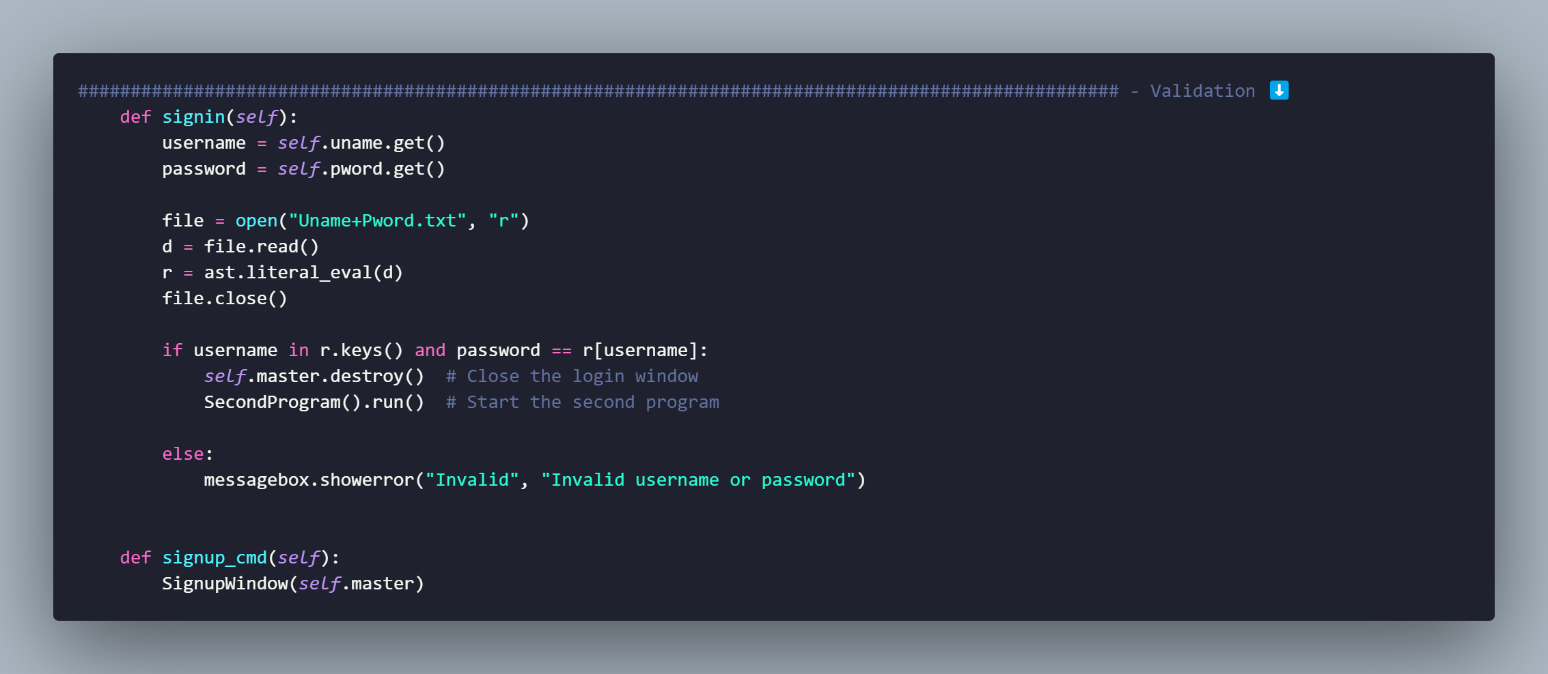

In this section of code, we see how a new window is made. This is where the users details are stored in the database, in the form Username : Password, but before this, when creating their account, before the details are saved, the user will have to enter their password twice to make sure that they typed the correct password, if they haven’t then an error message box will appear saying that the password do not match, and the program will not move on until they match.

##### Username and Password/Confirm Password

From video, timestamp: 0:17 – 0:26

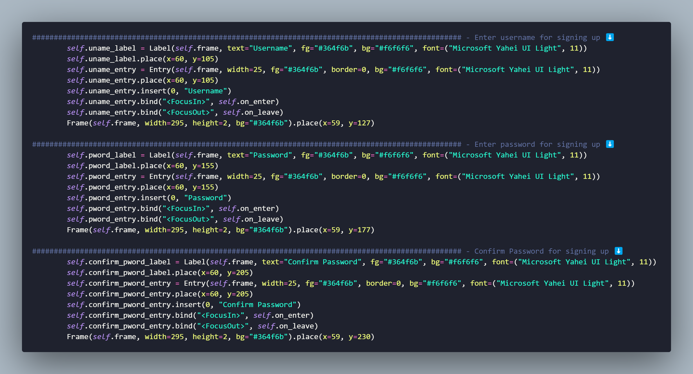

Here just shows the code, for each field that the user has to enter when creating a new account. Most of this is graphical, for example “FocusIn” and “FocusOut” leave the space blank when the user’s cursor is not hovering. As show by the photos below.

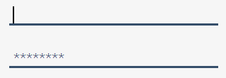 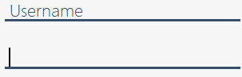

**Notes:** the same code is used when the user is logging in, with the same features.

##### Already have an account

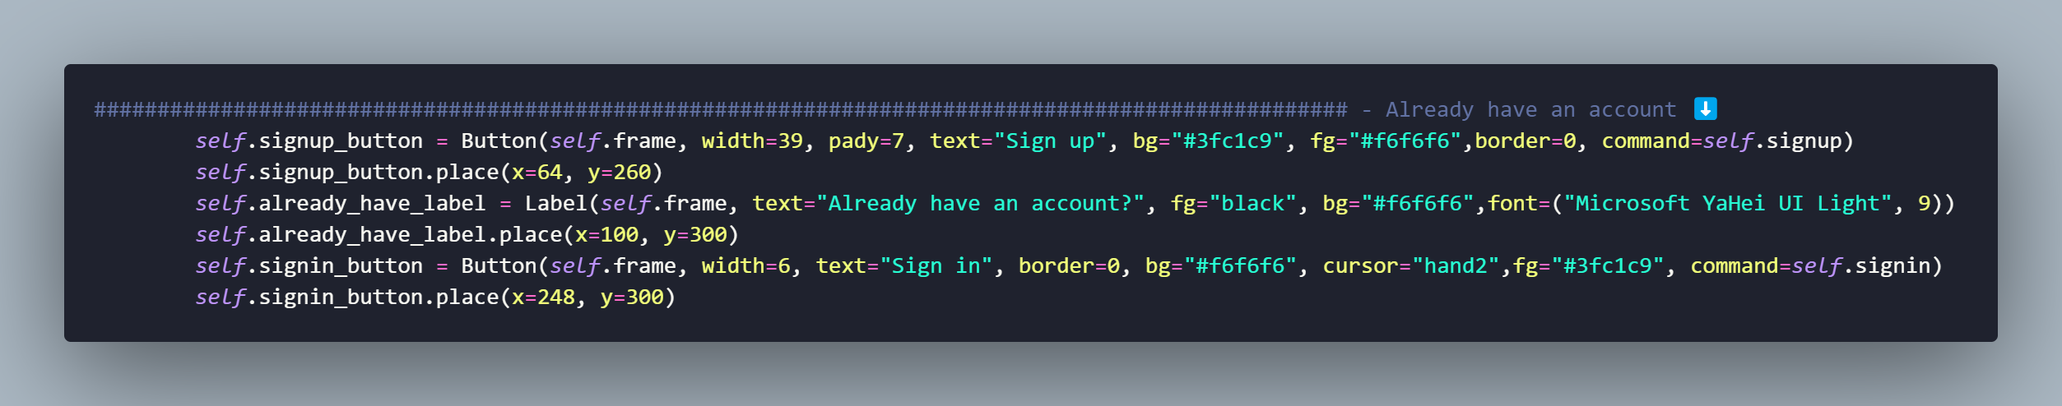

In this bit of code, the user is prompted to create an account. Buttons are created that will re-direct users to the correct page that they need to progress further. In this case the button made is called “Sign in” which will take the user to the Log in page.

##### Sign in or Create and account

From video, timestamp: 0:00 – 0:17

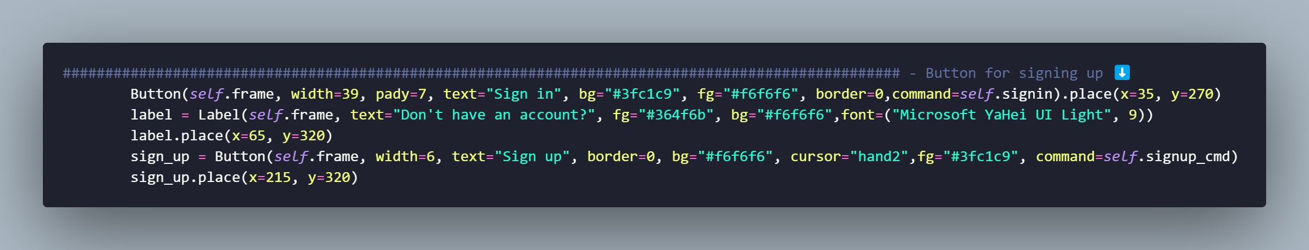

Similar to the *already have an account* this will be shown on the log in page, to prompt user that don’t have an account to make one so they can access the functions of the program. Buttons are created that will re-direct users to the correct page that they need to progress further. In this case the button made is called “Sign up” which will take the user to the Sign-up page.

### Exit program

From video, timestamp: 0:44 – 0:47

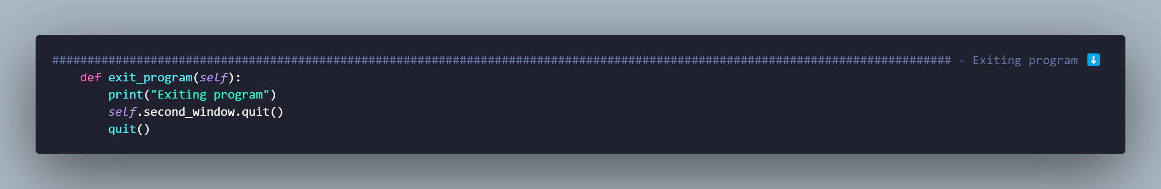

In this section the Exit function is defined where, when the user clicks on a button – that is defined later in the code, the program will close.

### Image upload program

From video, timestamp: 1:28 – 1:44

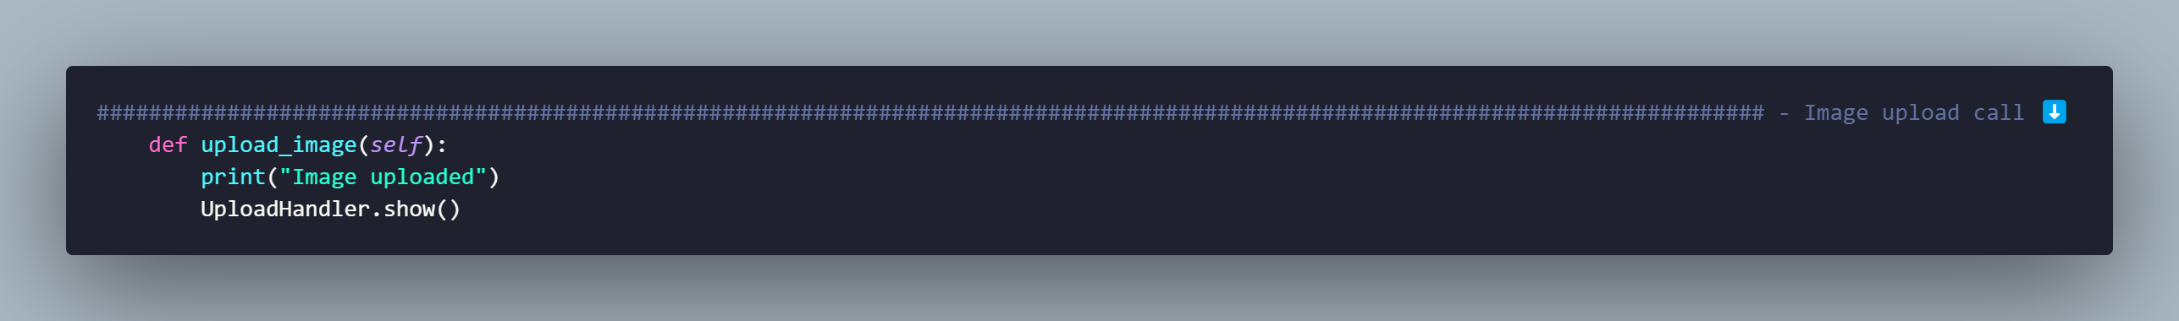

In this section of code, we see how the code calls upon the “UploadHnadler” class which is where the bulk of this section is written.

##### Upload handler

From video, timestamp shown throughout the timestamp 1:28 – 1:44

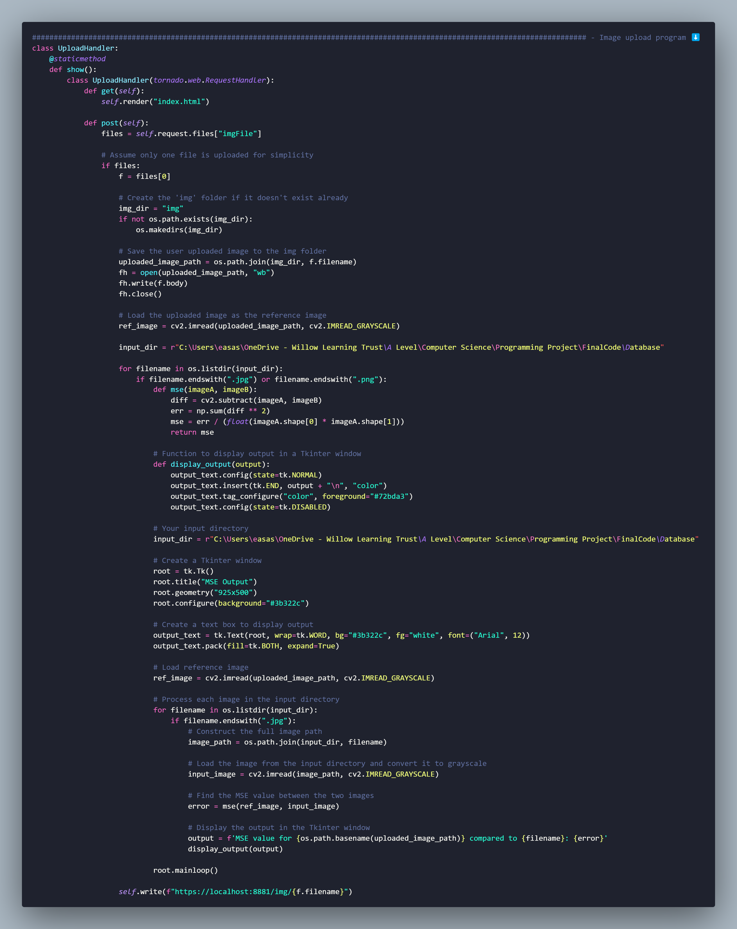

In this section of code, firstly we have reserved the port 8881 in this case, for a locally hosted server, where the user will upload their image so that it can be used in the program. We can see how the directory “img” is where the image that the user uploaded is stored. The program here also prepares the image for the MSE equation, and we can see this where the image is converted into greyscale, this is also done to all the files in the folder called “Database”. Once this is done the MSE equation is conducted. The user then sees an output of all the MSE values and can see what value was the highest. Additionally, at the top of the code we see how the program calls upon “index.htlm” which has all the aesthetic aspects of the server.

### Stop server

From video, timestamp: 1:58 – 2:02

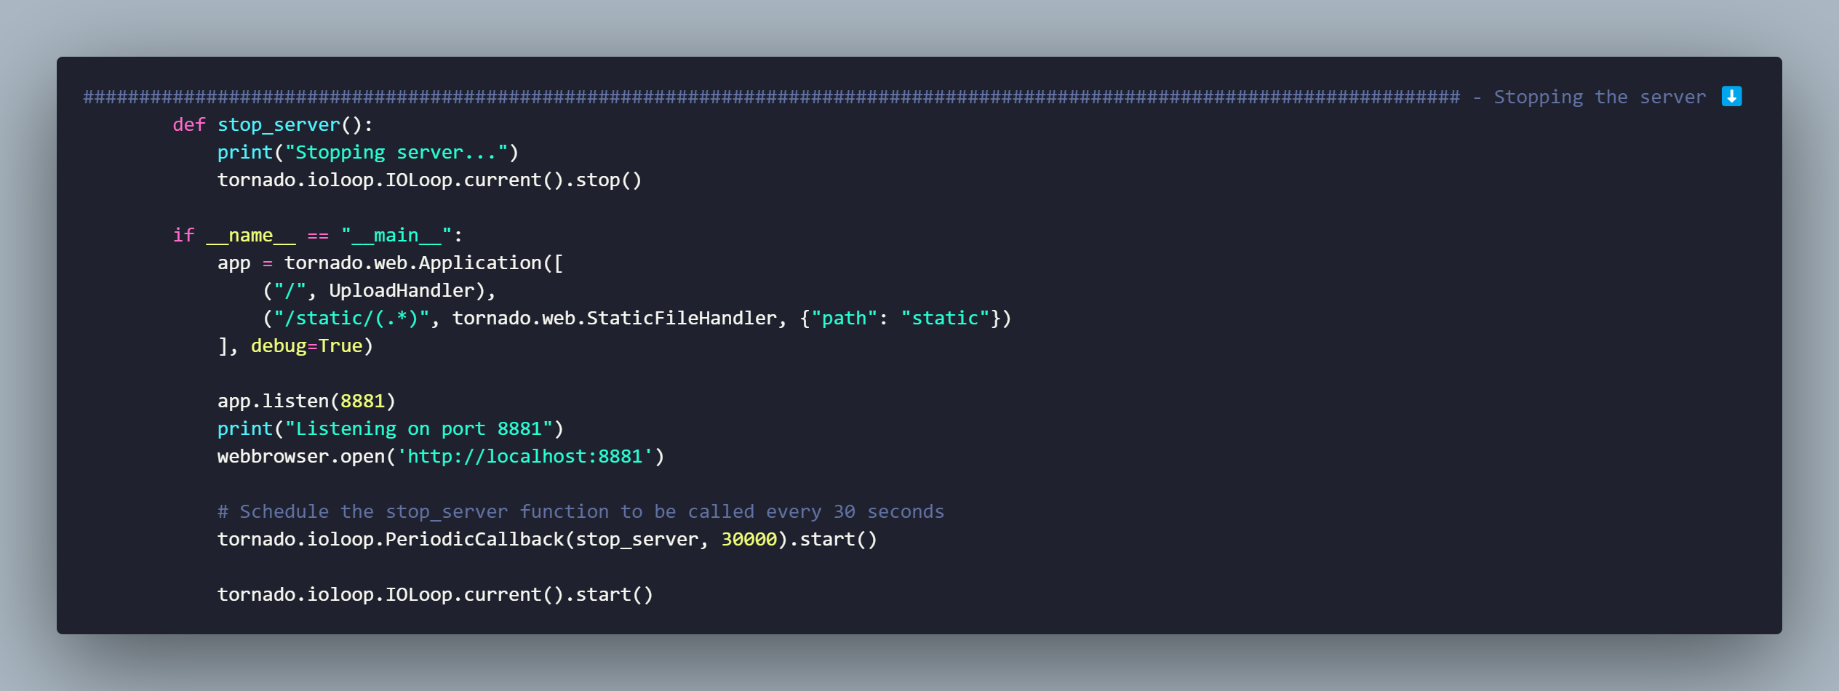

In this section we define another function called “stop_server” which stops the server when called upon. Furthermore, we have another piece of code that serves as a static file handler, which tells the python library Tornado, that there is a static file – the image on the website. Finally, the last lines of code tell us that after 30 seconds the “stop_server” function will be activated, and the server will be stopped.

### Home screen GUI

From video, shown throughout the video

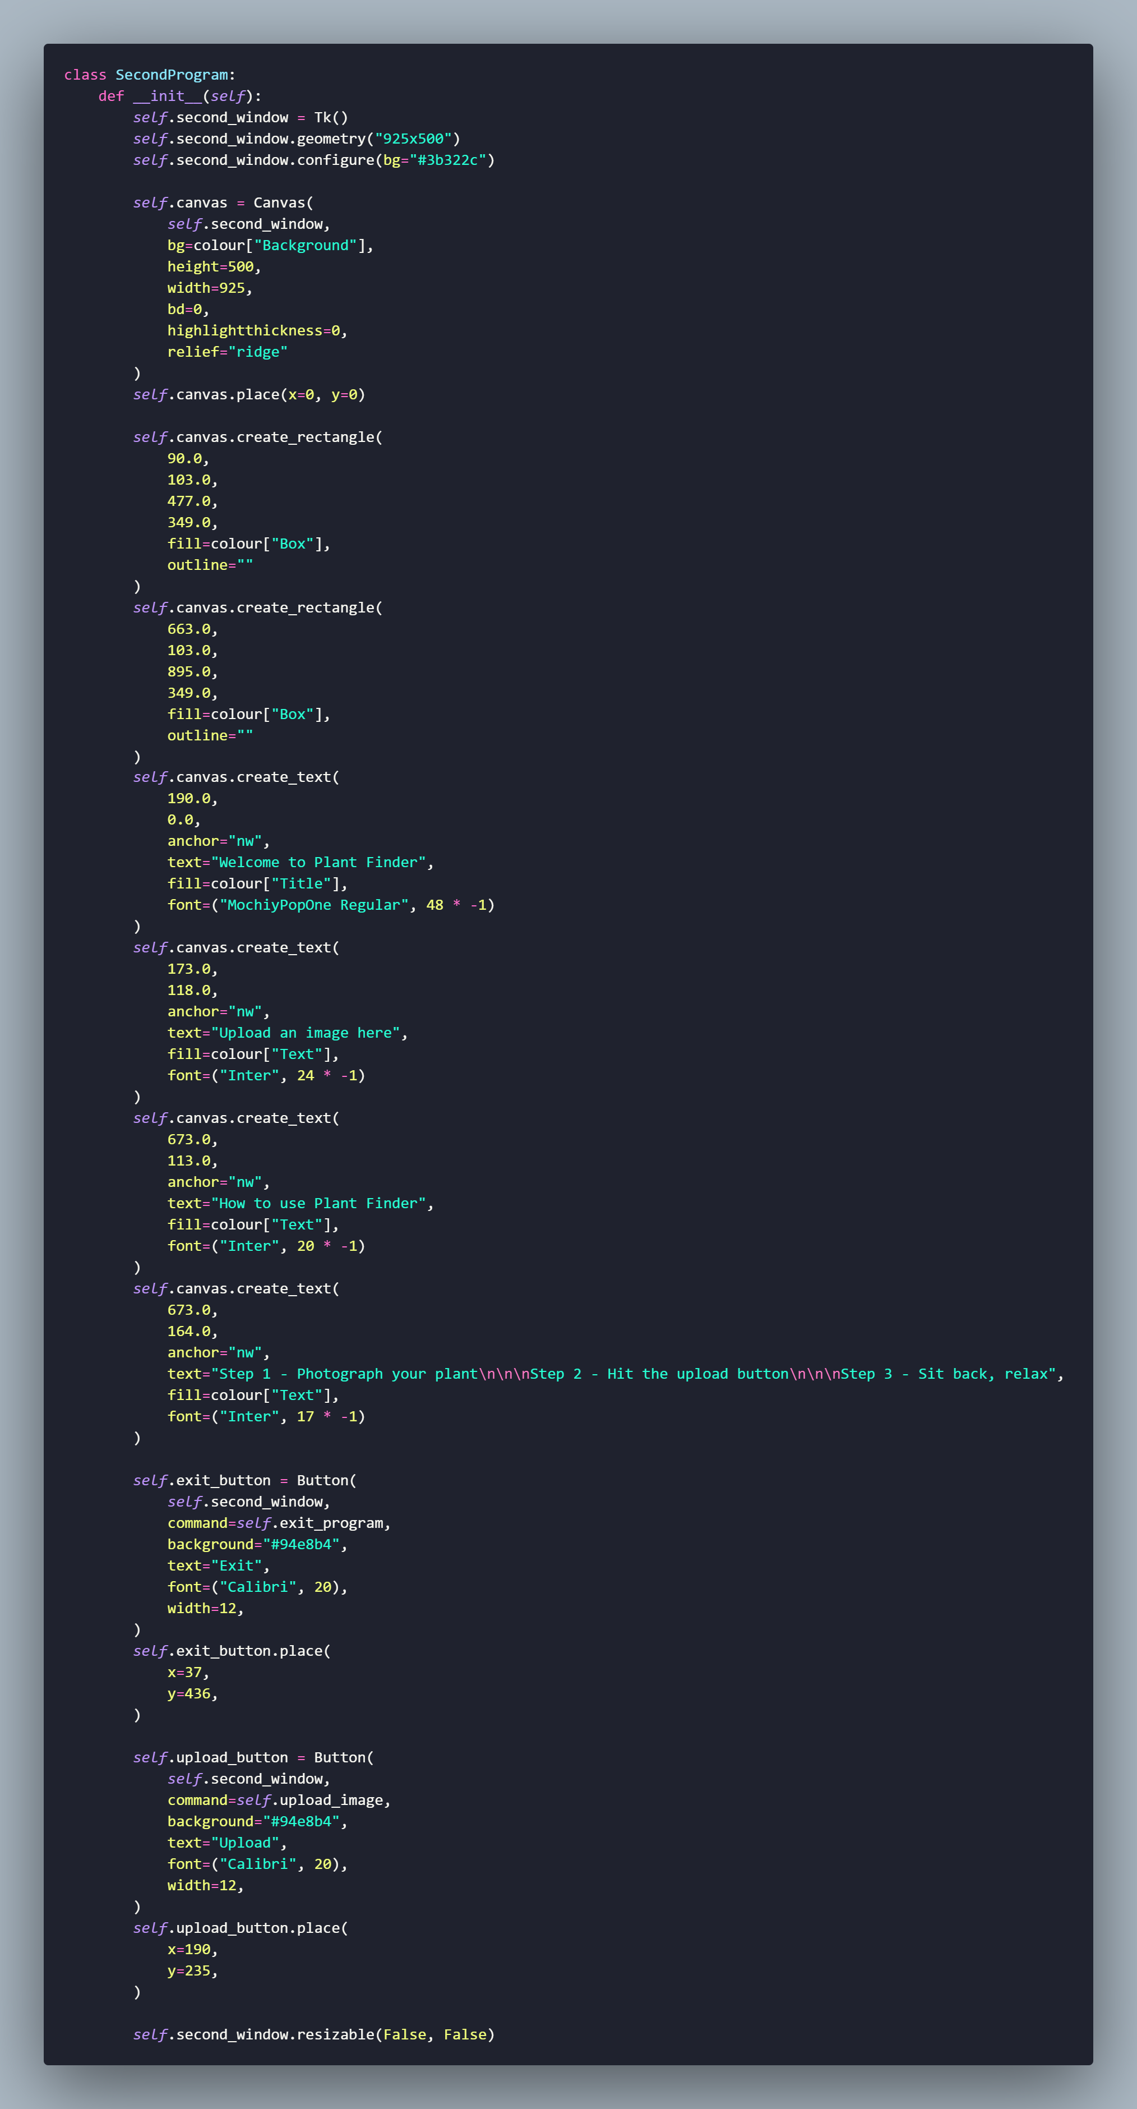

In this section of code, we are creating buttons and text for the home screen. As we can see here there are 2 buttons created, one for the exit program function which when clicked will call upon the “exit_program” function which was defined above, and another button for the upload an image code, which when clicked on will run the “image_upload” function.

## Dictionary

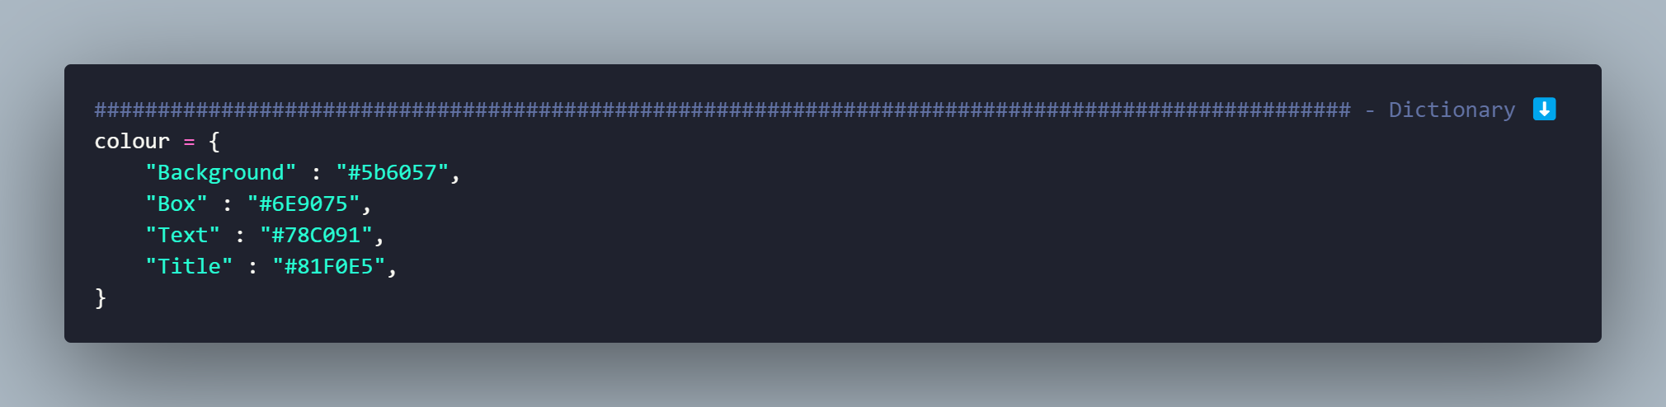

In here we can define colours that will be used throughout the code, but in this case are only used in the home screen GUI

## Meeting success criteria

In the section below using the video from the Video Showcase, I will be describing if I have met all the success criteria, mentioning what criteria I was and was not able to complete, and a justification for those not completed.

**Success criteria**

* Able to sign into an existing account or make a new account.
* Program is able to take an image as an input and store it.
* Able to convert all images to greyscale.
* Able to plot key points on all images that can be used to compare the images.
* Able to provide an MSE result for all image comparisons.
* Turn program into a mobile app, for even more accessibility.

Success criteria been met?

* I have successfully implemented the ability to log into an account or create a new account. New users are able to create new accounts and are able to log into existing accounts.
* The program is able to take in inputs in the form of images and store it - in JPG format only which is a limitation but something that cannot be helped at the moment in time as all files need to be of the same format, and the images used for the database are all stored as jpg files.
* The program can successfully convert all images inputted to greyscale
* The program can display key points for comparison. However, showing these key points to the user might result in a cluttered interface due to the considerable number of images.
* The program can provide an MSE output. However, due to the equation's nature and the photos being compared, anomalies in the values may occur. This issue was partially addressed by increasing the variety of images used in the comparison database.
* Due to time constraints, and due to a lack of aptitude surrounding making mobile apps, this criterion cannot be met

## Recommendation and Maintenance

Recommendation

Due to the nature of the program, and the way it uses the MSE function, the program can be used for more than just plants, it can be used for pretty much anything, as if the program would need to change to be based on cars for example, all the programmer would have to do is change the content of the database to images of cars, and instead of uploading a photo of a plant the user can upload a photo of a car, the program will still work with full functionality.

Maintenance

All functions have been properly and accurately named and designed so that in the future, anyone is able to read the functions and be able to know what it does, furthermore I have sectioned the code into each function and sub function so that it is easier for maintenance, as whoever is editing the program can easily scroll to the function they wish to edit/amend and start working. Throughout coding my program, I have made sure that it is future proof, adding various comments, explaining what some of the more complicated functions do and how they work, and as mentioned previously I have sectioned off the code into functions.

## Evaluation of solution

The objective of this NEA was to develop a solution that could effectively utilize reverse image searching, that is able to correctly identify plant. However, due to a combination of factors, the final product did not fully meet the original success criteria.

* Knowledge Constraints - One of the primary challenges faced during this project was a lack of knowledge and understanding of how to implement reverse image searching. This is a complex task that requires a good understanding of image processing and the use of APIs. Despite attempts to learn and apply this knowledge, the learning curve was steep and the time available was not sufficient to gain a complete understanding. This lack of aptitude was shown throughout the implementation stage, where I didn’t fully read up on how to go about implementing a reverse image searching AI, coupled with an advanced API, and due to this a backup plan was needed.
* Time Constraints - The project was also constrained by time. The process of learning about reverse image searching in depth, in order to successfully implement this, understanding how to use the relevant APIs, and then implementing this in code, is a time-consuming process. Given the limited time frame of the assessment, it was not possible to fully realize this aspect of the project. Furthermore, briefly mentioned in the database design section (Database Design) was the proposition to include the ability to re-set the users password in the case that they forgot. This feature was not implemented, as due to time constraints I was not able to implement this. Talking to another programmer, then process of implementing the ability to send an email to the respective user to rest their password using an API would prove to be very time consuming, this process would require extensive research, which would have taken a lot of time, if I had chosen to implement this. The programmer also said that “the email API was very difficult to implement” and “there is lots of room for error”, and based on these statements, I had made the executive decision to not include this feature.
* API Utilization - As a result of these constraints, the project did not make full use of the API for reverse image searching. The selected API can provide powerful functionality and can greatly enhance the capabilities of a project. However, they also require a certain level of understanding and technical skill to use effectively. In this case, the project was not able to leverage this resource to its full potential.
* Success Criteria - The original success criteria for the project included the effective use of reverse image searching. As this aspect of the project was not fully realized, the project did not meet its original success criteria. This is a clear area for improvement in future projects. Furthermore, due to the lack of knowledge, time constraints and consequently not fulfilling the success criteria, I lost a potential Stakeholder (999 operator). After relaying the changes in implementation, and the decisions made, the solution was no longer a viable option for them to consider, as image comparison is not good enough in the medical profession, they require trusted facts, and employing my program would not benefit them. This disheartened me as it my inexperience caused the loss of a potential stakeholder, and my solution would have been beneficial to them.

Conclusion - In conclusion, while this project did not fully meet its original objectives, it was a valuable learning experience. It highlighted the importance of having a solid understanding of the technologies being used, the need for effective time management, and the potential benefits of using APIs. These lessons will be invaluable in guiding future projects. A final brief overview of my project: Users have the option to log in or create a new account. They can upload an image to the program via a locally hosted server, which then redirects the image to a custom folder. In this folder, the program compares the uploaded image with others and calculates an MSE (Mean Squared Error) value. This value indicates the similarity between the uploaded image and the most similar one found in the folder, providing feedback to the user.

## Usability testing

Video evidence of one of my stakeholders – Jamie Burke, using the program for the first time:

<https://youtu.be/-x9gWCqDgKU>

### Feedback from stakeholder

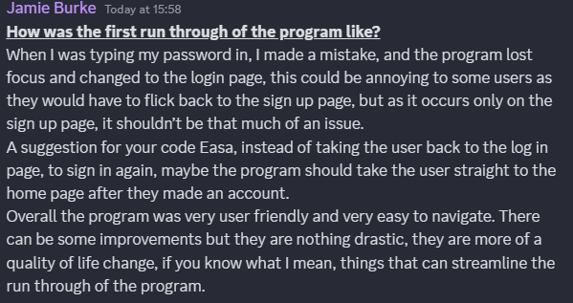After interacting with the program, Jamie said he liked how it worked, and how easy it was to create an account, and upload an image to the program, although he did mention how when the error message appeared at timestamp 0:24, the program lost focus and changed to the login page, he said that, that could be annoying to some users, but as it occurs only on the sign up page, it shouldn’t be that much of an issue. As a suggestion Jamie said that after signing up, instead of taking the user back to the log in page, to sign in again, maybe it should take the user straight to the home page. Overall, Jamie said that the program was very user friendly and easy to navigate, but there can be some improvements, nothing drastic but more quality-of-life changes, which can streamline the run through of the program.

The Original usability features were:

* Logging in/ signing up
* Uploading an image
* The user-friendly home screen
* File select
* Viewing/ output

All usability features were met except the viewing/output one. This was because of the change in implementation process, where originally reverse image searching was going to be able to identify the name of the plant, and use an API to return information on it, however now due the program not using that, viewing the information is no longer possible.

Future iterations

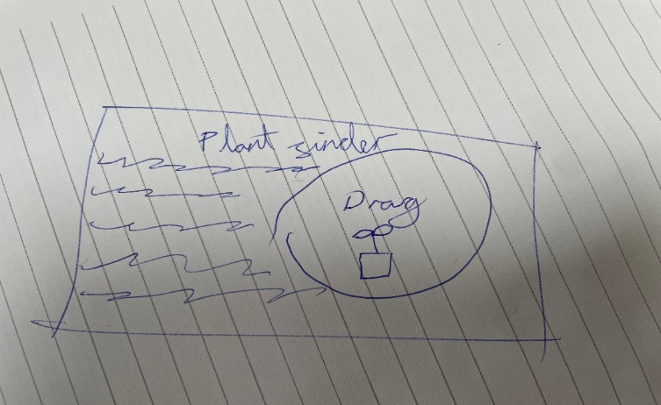Upon presenting my program to another stakeholder, they expressed satisfaction with its effectiveness in fulfilling its intended purpose. However, they provided constructive feedback for enhancement. Specifically, they suggested that future iterations of the program “integrate image upload functionality directly onto a single page rather than redirecting users to a locally hosted website.” Additionally, they recommended implementing a feature allowing “users to conveniently drag and drop images for upload, into the logo, for an overall cleaner aesthetic, once an image is uploaded the middle of the logo should disappear leaving just a circle with a photo display of the image the user uploaded.”

The picture shown shows the initial sketch that the stakeholder made. Below is an image of a refined version.

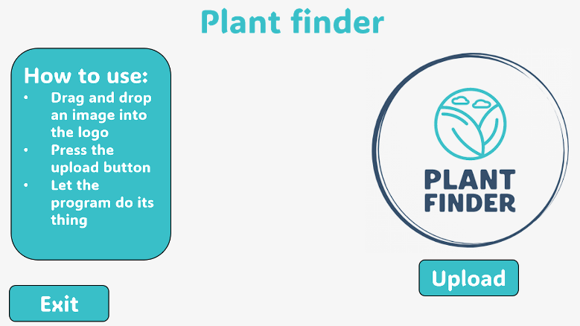

Users would drag and drop images to this location of the program(which would act as the locally hosted server in my current program)

Upon reviewing the statement, the idea having everything on one page would be much more ideal and easier to navigate, and as they, said my solution can have a “cleaner, more professional, aesthetic” look to the program. Futhermore the incorporation of a drag and drop feature would be much more easier and convenient for the user, as they can just upload any image straight to the program without having to search through their file explorer.

# References

1. Buymobiles. “How to Use Google Lens on Your IPhone or IPad.” Your Mobile., 10 June 2021, www.buymobiles.net/blog/how-to-use-google-lens-on-your-iphone-or-ipad/. Accessed 13 Apr. 2024.
2. “Filedialog to Browse and Upload Image File Using Askopenfilename() Function and Display in Tkinter.” Www.plus2net.com, www.plus2net.com/python/tkinter-filedialog-upload-display.php.
3. Gupta, Aryan. “Redirect Notice.” Google.com, 2024, www.google.com/url?sa=i&url=https%3A%2F%2Fwww.simplilearn.com%2Ftutorials%2Fstatistics-tutorial%2Fmean-squared-error&psig=AOvVaw0HY62CGlnN3Vt7cRz8e-z0&ust=1707997210110000&source=images&cd=vfe&opi=89978449&ved=0CBMQjRxqFwoTCPiy1MnfqoQDFQAAAAAdAAAAABAE. Accessed 13 Apr. 2024.
4. Khan, Shahid. “How to Compare Two Images in OpenCV Python.” Www.tutorialspoint.com, www.tutorialspoint.com/how-to-compare-two-images-in-opencv-python.
5. “Nerium Oleander L. | Plants of the World Online | Kew Science.” Plants of the World Online, powo.science.kew.org/taxon/urn:lsid:ipni.org:names:80460-1.
6. Pravat Computer Technology. “How to Create Login Form for Apps Using Python | Tkinter Project #Part1.” Www.youtube.com, 27 Mar. 2022, www.youtube.com/watch?v=X9reTI_Mckk&pp=ygUecHJhdmF0IGNvbXB1dGVyIHNjaWVuY2UgbG9nIGlu. Accessed 13 Apr. 2024.
7. Taesang. “Free Plant API | Houseplants,Garden,Trees,Flowers,Images & Data.” Perenual.com, perenual.com/docs/api. Accessed 13 Apr. 2024.
8. “This Classic Rose Was Once a Symbol of War.” House Beautiful, 31 Mar. 2023, www.housebeautiful.com/lifestyle/gardening/a43472680/white-roses-meaning/.
9. Truly, Alan. “PictureThis: The Best Plant Identifier Camera App.” PetaPixel, 22 Feb. 2023, petapixel.com/picturethis-best-plant-identifier-app/.
10. user5587030. “Can’t Install Tensorflow with Pip or Anaconda.” Stack Overflow, 20 July 2018, stackoverflow.com/questions/51440475/cant-install-tensorflow-with-pip-or-anaconda. Accessed 19 Apr. 2024.

# Appendix

## Complete program code

Below are screenshots off my complete program code, with all finalised changes and amendments made

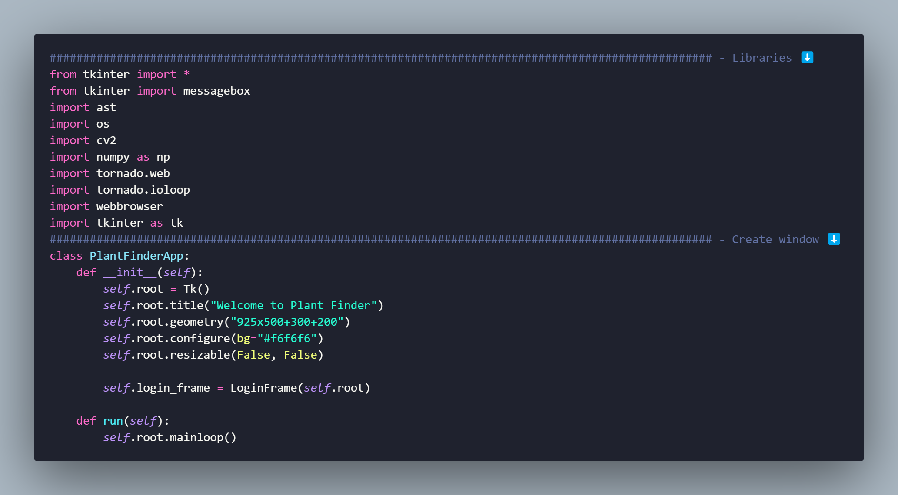

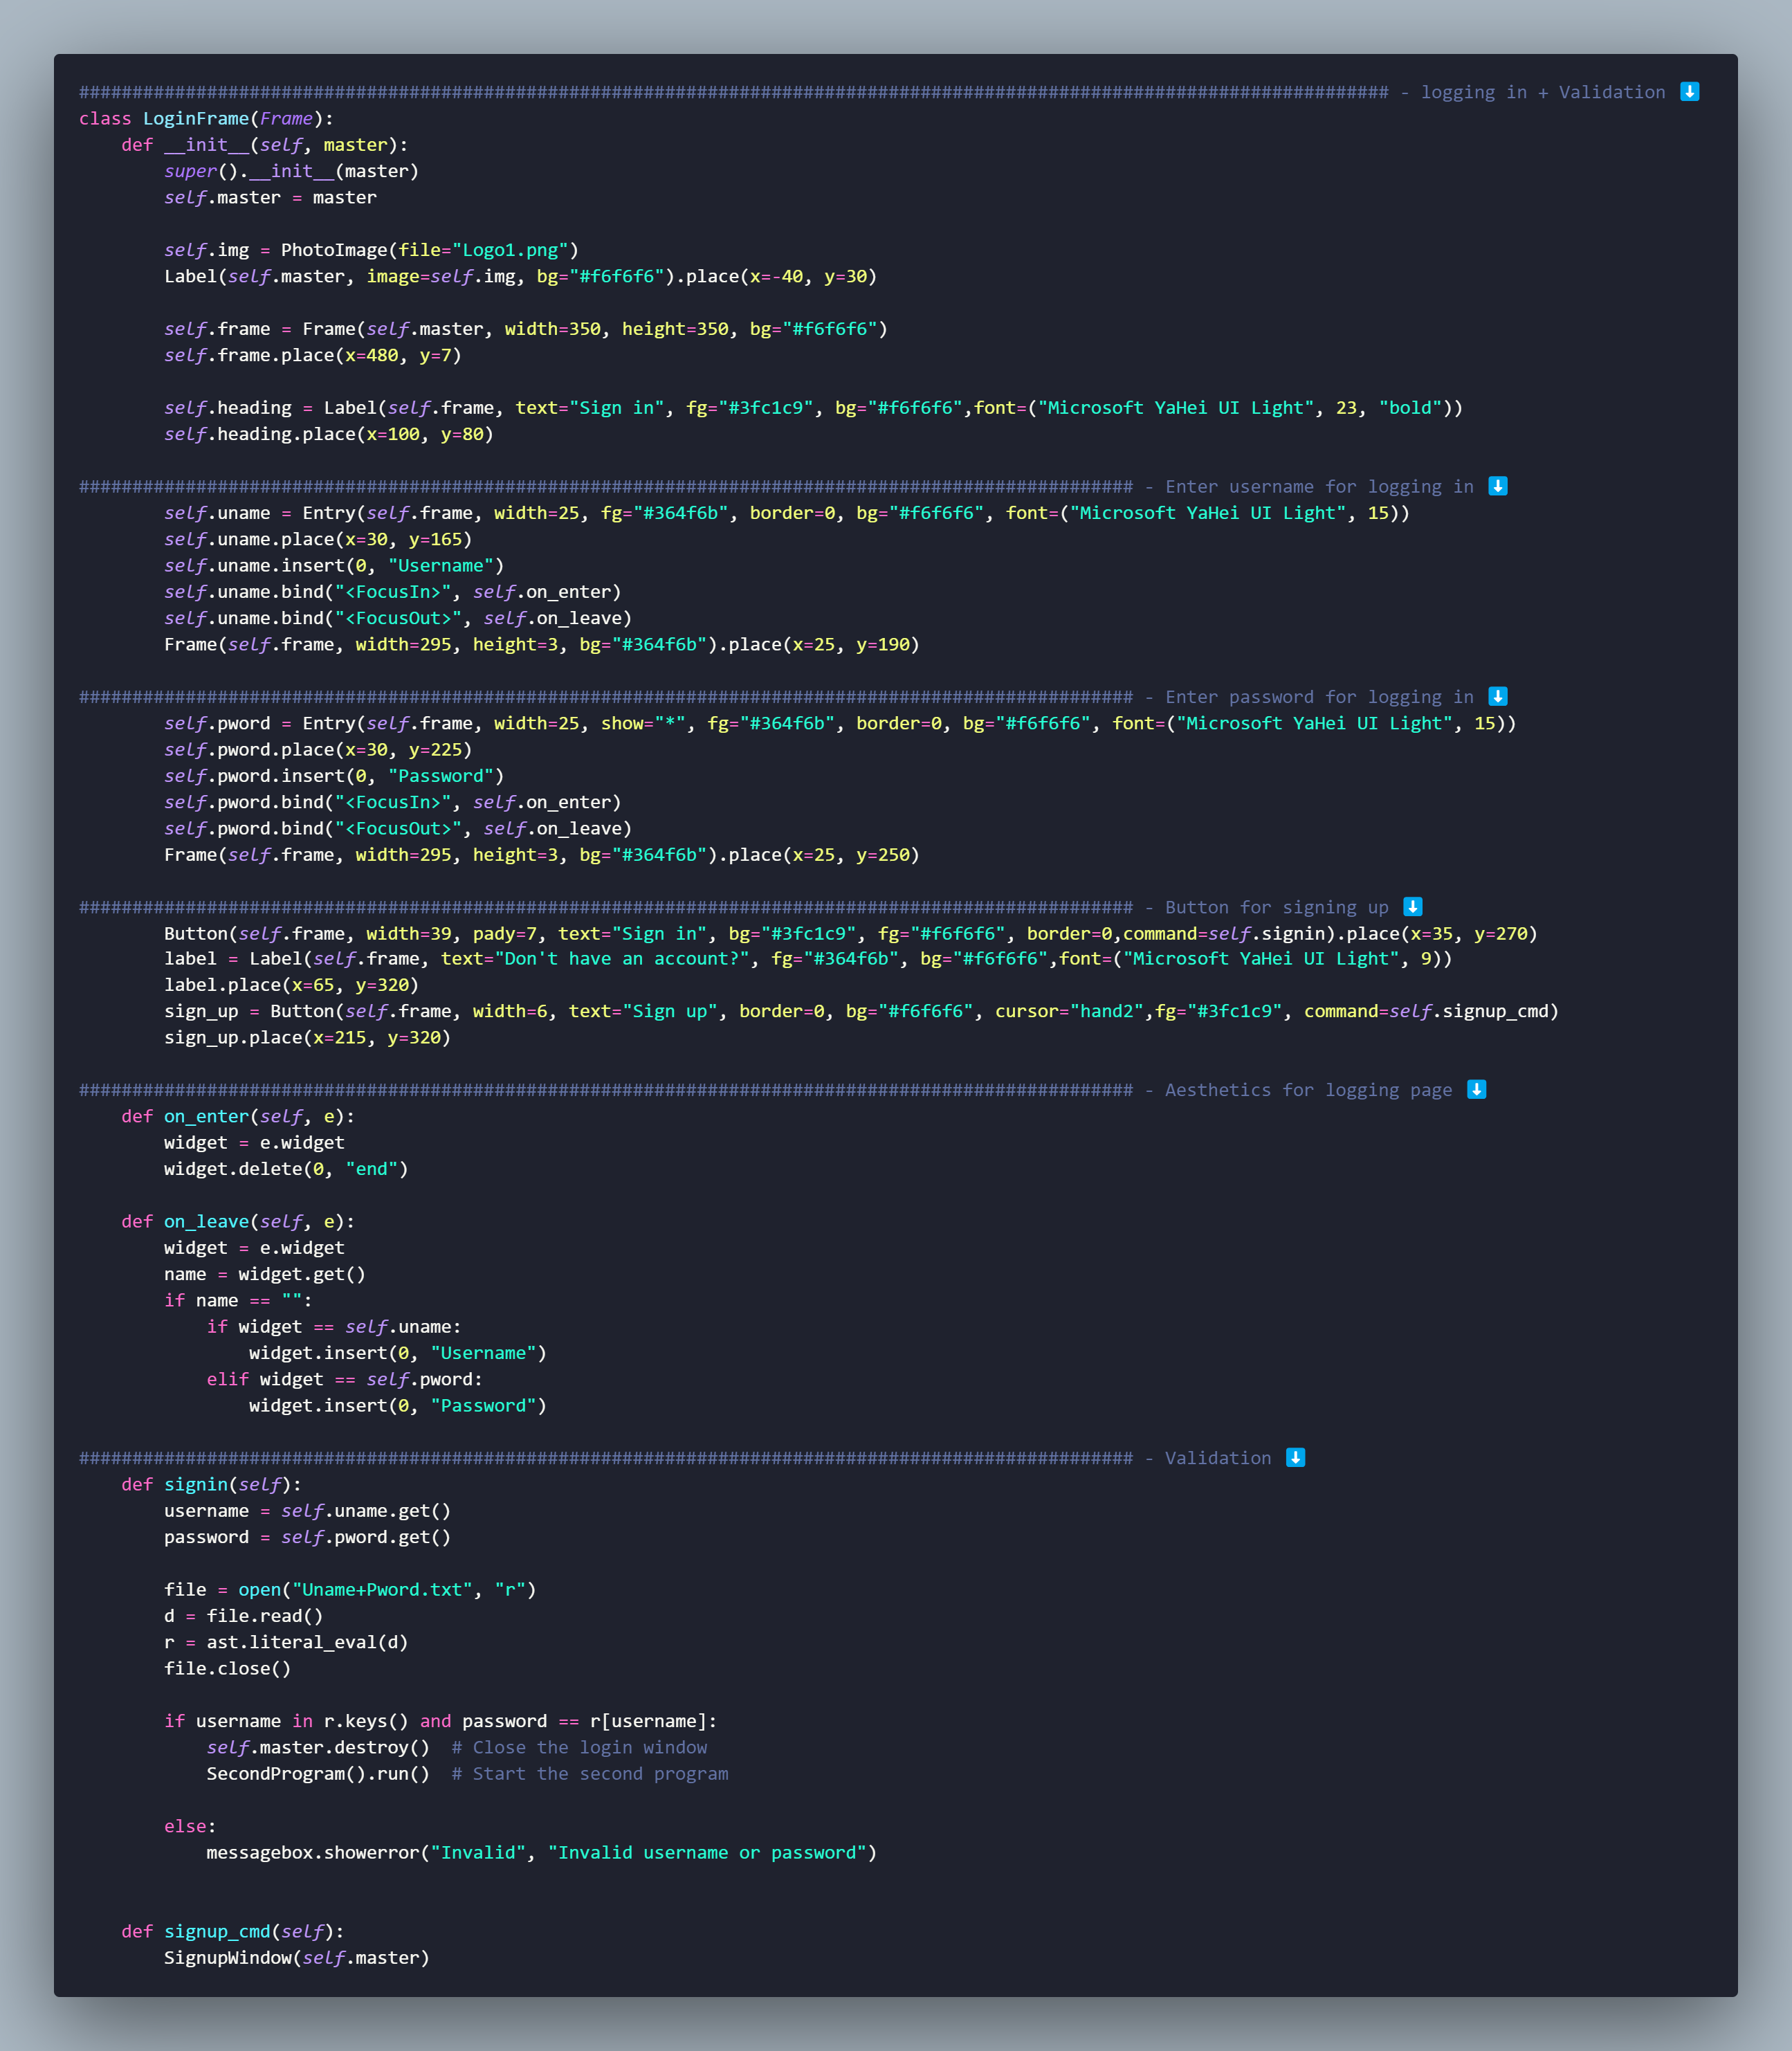

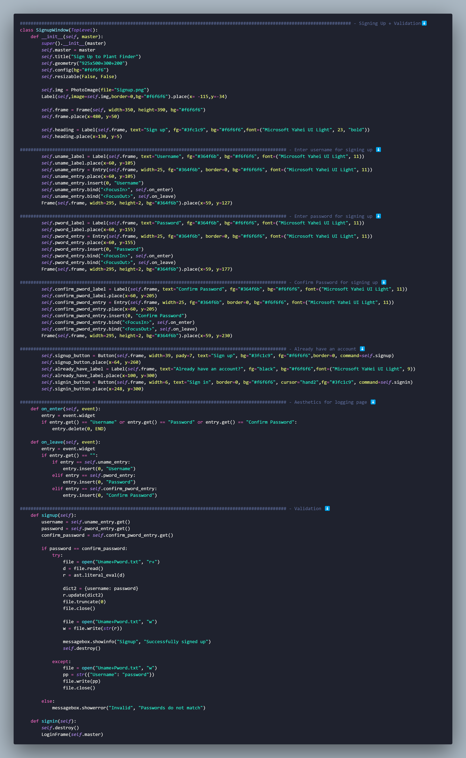

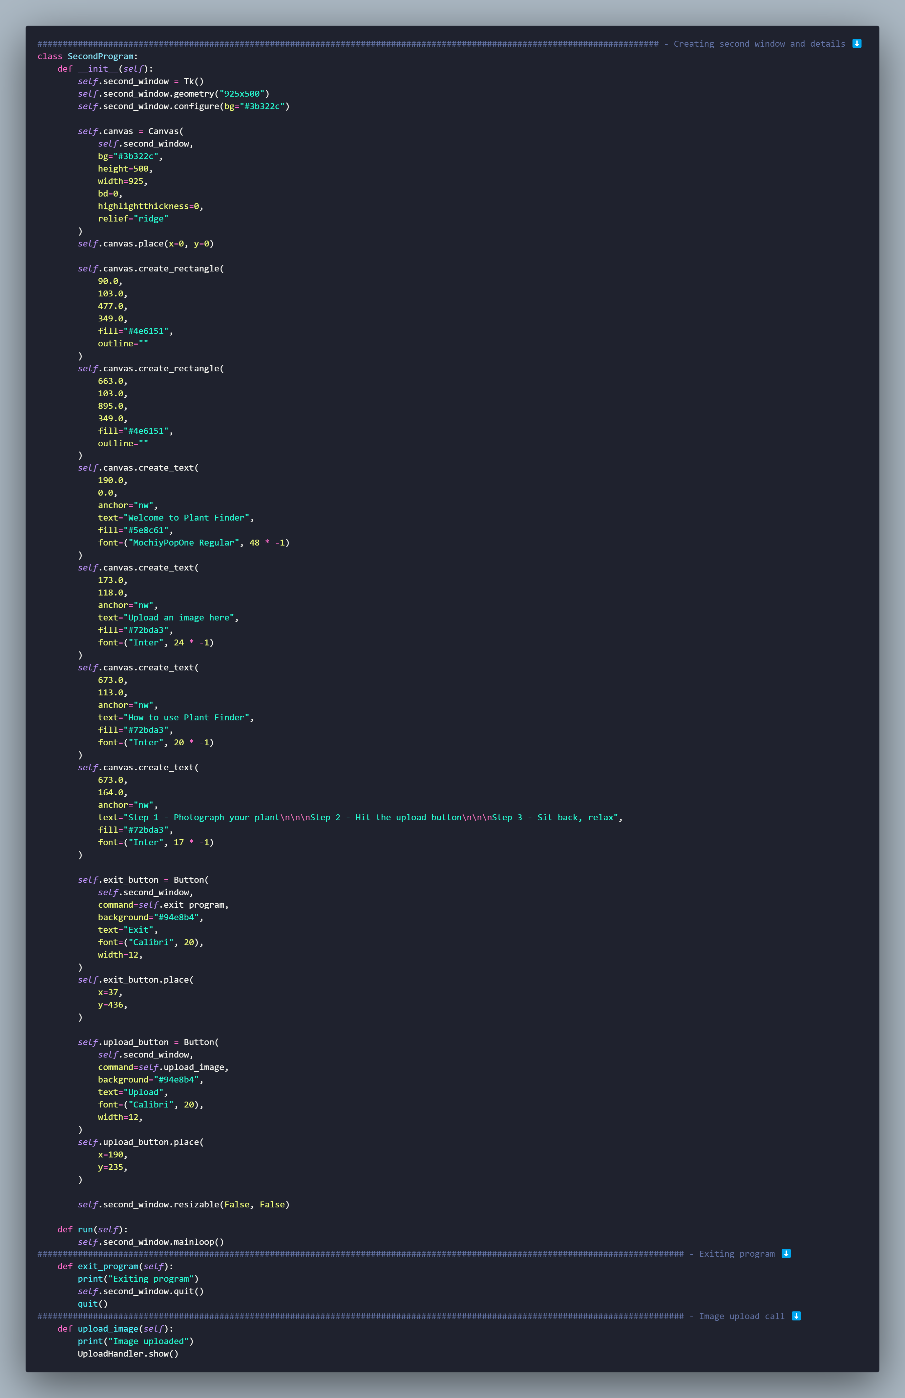

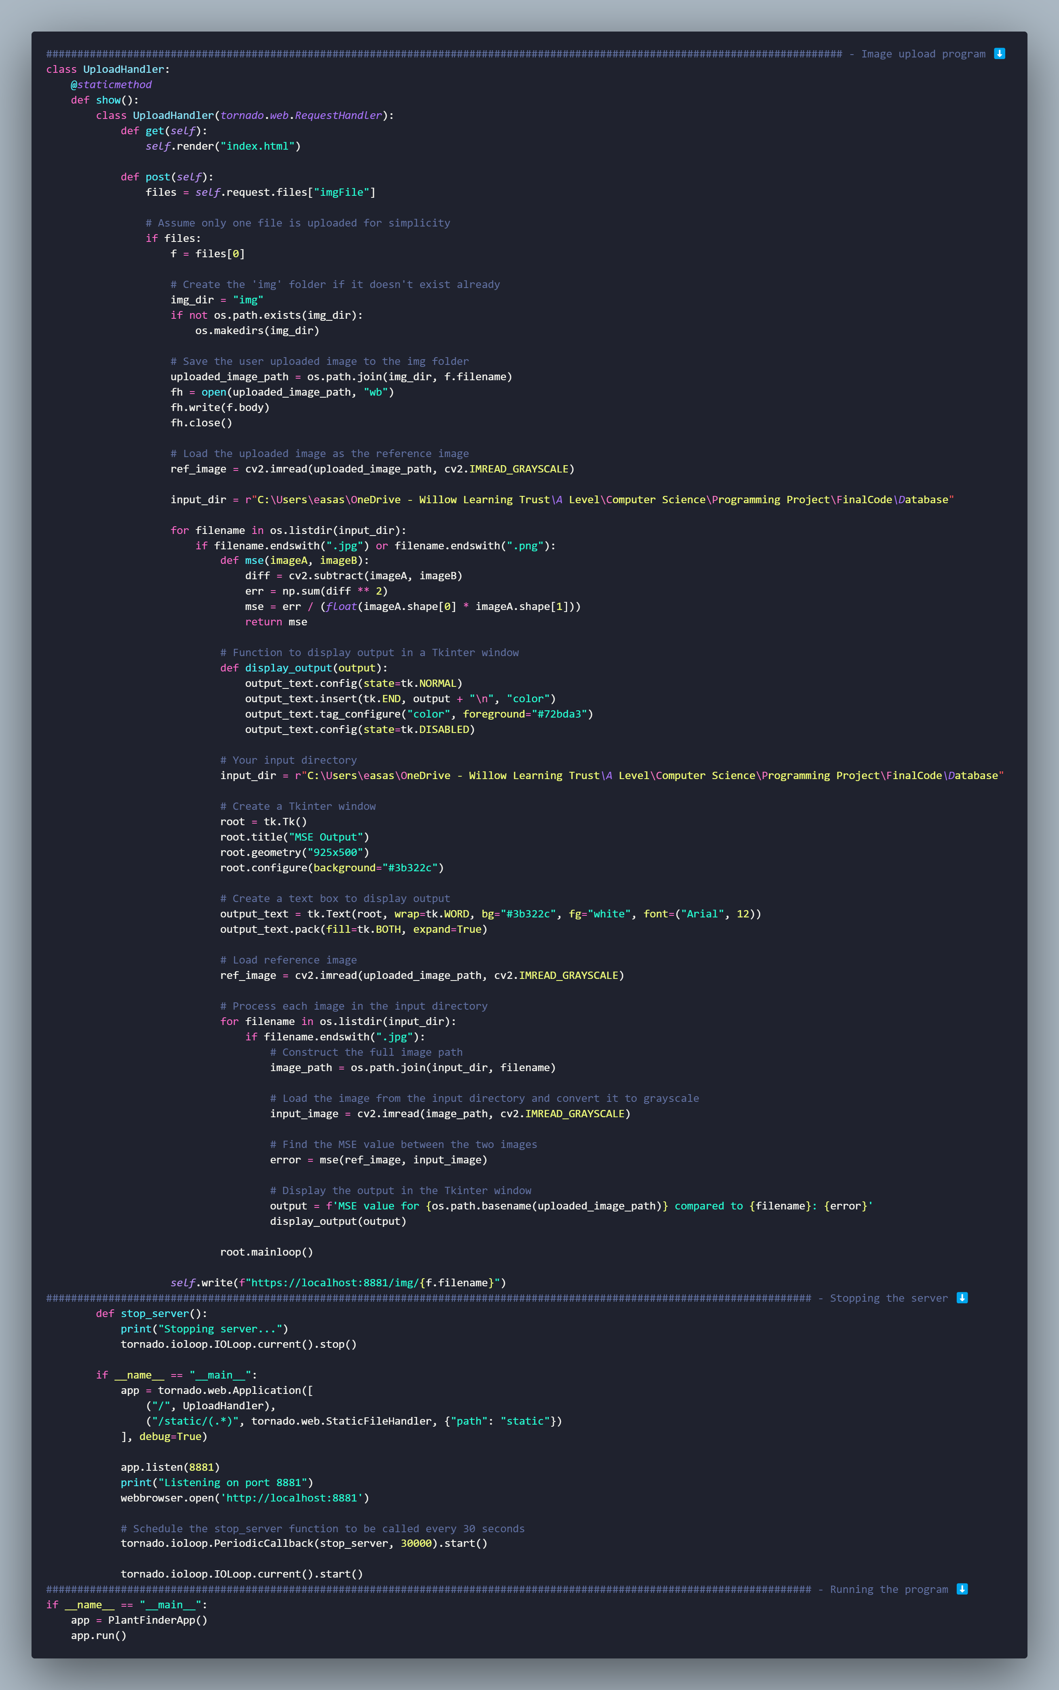

1. Anon, (2020). *Top Problems Faced By Beginning Gardeners - NatureZedge*. [online] Available at: https://naturezedge.com/top-problems-faced-by-beginning-gardeners.
2. Enfield, B., Brooks, D.R., Welch, S., Roland, M., Klemens, J., Greenlief, K., Olson, R.E. and Gerkin, R. (2018). Human Plant Exposures Reported to a Regional (Southwestern) Poison Control Center Over 8 Years. *Journal of Medical Toxicology*, [online] 14(1), pp.74–78. doi:https://doi.org/10.1007/s13181-017-0643-3.
3. Piccione, N. (2021). *When should you worry about frequent forgetfulness?* [online] OSF HealthCare Blog. Available at: https://www.osfhealthcare.org/blog/when-should-you-worry-about-frequent-forgetfulness/#:~:text=Many%20common%20conditions%20and%20even.
4. Gutierrez, K. (2019). *Studies Confirm the Power of Visuals in eLearning*. [online] Shiftelearning.com. Available at: https://www.shiftelearning.com/blog/bid/350326/studies-confirm-the-power-of-visuals-in-elearning.
5. Froberg, B., Ibrahim, D. and Furbee, R.B. (2007). Plant Poisoning. *Emergency Medicine Clinics of North America*, 25(2), pp.375–433. doi: <https://doi.org/10.1016/j.emc.2007.02.013>.
6. www.google.com. (n.d.). *how many pink flowers are there - Google Search*. [online] Available at: <https://www.google.com/search?client=operagx&q=how+many+pink+flowers+are+there&sourceid=opera&ie=UTF-8&oe=UTF-8#cobssid=s> [Accessed 14 Nov. 2023].
7. Wikipedia Contributors (2019). *Google Lens*. [online] Wikipedia. Available at: https://en.wikipedia.org/wiki/Google_Lens.
8. Plantsnap - Identify Plants, Trees, Mushrooms With An App. (2019). *Who We Are - PlantSnap Mobile App - Plant Identifier App*. [online] Available at: https://www.plantsnap.com/who-we-are/.
9. blossomplant.com. (n.d.). Blossom - Plant Care Companion. [online] Available at: https://blossomplant.com/.
10. https://stackoverflow.com/questions/51440475/cant-install-tensorflow-with-pip-or-anaconda